PROJECT REPORT

on

**Development of an Application for Pets**

### *Submitted By*

###### Mr. YASH KASHTI Mr. SAHIL MAHATO

###### Mr. AMAN ILATKAR Mr. YASH CHIKTE

**Mr. VEDANT CHIMOTE**

Submitted in partial fulfillment of the requirements

for

Degree of Bachelor of Engineering

# Guided By :-

1. **Mr. SWAPNIL MAHAJAN**
2. **Ms. NIKITA JAMGADE**



**DEPARTMENT OF COMPUTER SCIENCE & ENGINEERING**

1. **S.B. JAIN INSTITUTE OF TECHNOLOGY, MANAGEMENT & RESEARCH, NAGPUR.**

(An Autonomous Institute, Affiliated to RTMNU, Nagpur)

**2022-2023**

**© S.B.J.I.T.M.R Nagpur 2023**

******DECLARATION**

i

We, hereby declare that the Project titled **“Development of an Application for Pets”** submitted herein has been carried out by us in the Department of Computer Science & Engineering of S. B. Jain Institute of Technology Management and Research, Nagpur under the guidance of **Mr. Swapnil Mahajan** and **Ms. Nikita Jamgade**. The work is original and has not been submitted earlier as a whole or in part for the award of any degree / diploma at this or any other Institution / University.

**YASH KASHTI**

**SAHIL MAHATO**

**AMAN ILATKAR**

**YASH CHIKTE**

**VEDANT CHIMOTE**

**Date: - / /**

**ACKNOWLEDGEMENT**

ii

We would like to express deep sense of gratitude to our Project Guide, **Mr. Swapnil Mahajan** and **Ms. Nikita Jamgade**, **Department of Computer Science & Engineering**, for being the cornerstone of our project. It was her incessant motivation and guidance during periods of doubts and uncertainties that has helped us to carry on with this project.

We would like to thank **Dr. Mrudula Nimbarte**, **Head of Department**, **Computer Science & Engineering** for providing the necessary guidance, support, motivation and inspiration without which this project would not have been possible.

We would like to extend our special thanks to **Dr. S. L. BADJATE**, **Principal** of **S.B. Jain Institute of Technology, Management & Research** for his encouragement and best wishes.

We would like to extend our sincere thanks to the **Management** of **S.B. Jain Institute of Technology, Management & Research** for providing all the necessary infrastructure and laboratory facilities.

We also like to acknowledge the help extended by the **faculty members and non-teaching staff** of Computer Science & Engineering Department for successful completion of our project.

Last but not the least, special thanks to our family members, friends and colleagues for their continuous support.

iii

**ABSTRACT**

Pet Buddy is an Android application where grooming, veterinary services, and selling of pets as well as pet products take place. We came to know that most of the people belong to nuclear families, and they need their pets to be groomed and trained in their absence. The problem that arises here is that they don’t have proper guidance, and they don’t get proper information on the internet about such organizations or shops that provide such services for their pets. Through this project, we are planning to digitalize this process through online marketing. Thus, the person can also rely on different shops across the city that provides grooming services. People could also learn about the different price ranges for the same service offered by different shops according to their location. Thus, our app provides a platform where the user can book grooming as well as veterinary services according to his or her convenience for his or her pet and get services delivered to their doorstep. Basic pet grooming includes combs and brushes, bathing, shampoos and conditioners, and nail clipping and trimming. Our app includes special features for users such as tracking pets' vet histories and purchasing pet food, as well as grooming, day care, and pet boarding services from the information provided. Through this, we desire to contribute something to the people who have a hybrid lifestyle and need such services. We build an Android application in such a way that we create a login for all users. After logging in, the user is directed to the homepage, where he or she can see all the services provided by various providers across the city. Besides these, one could see options for selecting various services and buying pet food.

*Index Terms ­- Grooming, Training, Veterinary, Pet, Adoption.*

iv

# **INDEX**

**PAGE No**.

**CERTIFICATE……………………………………………………………………………………….** i

**DECLARATION………………………………………………………………………………………**ii

**ACKNOWLEDGEMENT……………………………………………………………………………**iii

**ABSTRACT…………………………………………………………………………………………..** iv

**INDEX…………………………………………………………………………………………………**v-vi

**LIST OF FIGURES…………………………………………………………………………………...**vii

**LIST OF PUBLICATION/PARTICIPATIONS/COPYRIGHT…………………………………...**viii

**CHAPTER 1 INTRODUCTION**

**1.1 PROJECT BACKGROUND** 1

**1.2 PROBLEM STATEMENT** 1

**1.3 PURPOSE OF STUDY** 2

**1.4 TECHNOLOGICAL BASE** 3

**CHAPTER 2 LITERATURE SURVEY**

**2.1 HISTORICAL STUDY** 10

**2.2**  **RELATED WORK** 11

**2.3 REAL TIME SURVEY** 15

**Chapter 3 METHODOLOGY/ PROPOSED SOLUTION**

**3.1 PROPOSED WORK**  17

**3.2 SYSTEM ARCHITECTURE** 19

**3.3 SYSTEM FLOWCHART**  20

**Chapter 4 TOOLS/ PLATFORM**

**4.1 SOFTWARE REQUIREMENT** 21

**4.2 HARDWARE REQUIREMENT** 29

**CHAPTER 5 DESIGN & IMPLEMENTATION**

**5.1 SYSTEM DESIGN** 30

**5.1.1 USE CASE DIAGRAM** 30

**5.1.2 CLASS DIAGRAM** 32

**5.1.3 SEQUENCE DIAGRAM** 33

v

**5.2 IMPLEMENTATION OF SYSTEM** 35

**5.2.1 IMPLEMENTED MODULES** 35

**5.2.2 SAMPLE CODE** 36

**Chapter 6 TESTING, RESULTS & DISCUSSION**

**6.1 TESTING** 42

**6.1.1 TYPES OF TESTING** 42

**6.1.2 LEVELS OF TESTING** 44

**6.1.3 TESTING REPORT** 45

**6.2 RESULTS AND DISCUSSION** 50

**Chapter 7 ADVANTAGES & APPLICATIONS**

**7.1 ADVANTAGES** 57

**7.2 APPLICATIONS** 58

**Chapter 8 CONCLUSION AND FURTHER SCOPE**

**8.1 CONCLUSION** 59

**8.2 FURTHER SCOPE** 59

**REFERENCES**

**APPENDIX I PARTICIPATION CERTIFICATES**

**APPENDIX II PUBLISHED PAPER COPY**

**APPENDIX III PLAGIARISM REPORT**

**APPENDIX IV INSTRUCTION MANUAL**

**APPENDIX V COPYRIGHT PUBLICATION**

### 

vi

### **LIST OF FIGURES**

|  |  |  |
| --- | --- | --- |
| **FIG NO**. | **TITLE OF FIGURE** | **PAGE NO.** |
| **3.2** | SYSTEM ARCHITECTURE | 19 |
| **3.3** | SYSTEM FLOW CHART | 20 |
| **5.1.1** | USE CASE DIAGRAM | 30 |
| **5.1.2** | CLASS DIAGRAM | 32 |
| **5.1.3** | SEQUENCE DIAGRAM | 33 |
| **6.2.1** | CUSTOMER SIGNUP | 50 |
| **6.2.2** | LOGIN PAGE | 50 |
| **6.2.3** | HOME PAGE | 51 |
| **6.2.4** | SERVICES LIST | 51 |
| **6.2.5** | CONTACT US | 52 |
| **6.2.6** | PRODUCT INFORMATION | 52 |
| **6.2.7** | GROOMING | 53 |
| **6.2.8** | VET CONSULTANCY | 53 |
| **6.2.9** | CHECKOUT | 54 |
| **6.2.10** | PAYMENT | 54 |
| **6.2.11** | ORDER DETAILS | 55 |
| **6.2.12** | ADMIN DASHBOARD | 55 |
| **6.2.13** | ADMIN USER DETAILS | 56 |
| **6.2.14** | ADMIN ORDERS | 56 |

vii

**LIST OF PUBLICATION/PARTICIPATIONS/COPYRIGHT**

|  |  |  |  |  |
| --- | --- | --- | --- | --- |
| **Sr No** | **Title** | **Event Name /Journal Name/ Conference/Diary No. of Copyright** | **Date** | **Remark** |
| **1** | Development of an Application for Pets | International Journal Of Novel Research And Development | 27/03/2023 | Paper Published |
| **2** | Development of an Application for Pets | SCEECS ’23, MAULANA AZAD NATIONAL INSTITUTE OF TECHNOLOGY, BHOPAL | 18/03/2023 | International Student Conference |
| **3** | Development of an Application for Pets | Guru Nanak Institute of Engineering & Technology, Nagpur | 19/04/2023 | Project Competition |
| **4** | Development of an Application for Pets | Diary No: 7480/2023-CO/L | 21/03/2023 | Applied for Copyright |

viii

## CHAPTER NO. 1

## INTRODUCTION

## CHAPTER 1

**INTRODUCTION**

* 1. **1.1 PROJECT BACKGROUND**

India is one of the fastest growing pet care markets in the world. This growth is lead by factors such as rising incomes, nuclear family and changing attitude towards pet and pet owners. Around 30,000 people adopted pets in the pandemic. According to a survey business such as grooming, hospitality also witnessed a surge from 22% to 29%. According to the Times of India pet styling industry has grown in few years. A large amount of revenue is generated through this business.

Pet owners are increasingly treating their pets as their own child. They are treated as their own family members and the owners are willing to invest lots of money on them so that they are best in their health and looks. Another important workplace trend is working longer hours and more days. There is also the traveling professional. Professionals are looking for help to care their pets in a loving playful daycare. There is a need to have pets cared for over long periods of time while their owners are away.

* 1. **1.2 PROBLEM STATEMENT**

As we know today’s trend consists of professionals having their families in later in life or deciding not to have children at all. Pet isn’t just part of family anymore; they are the family. Pet owners are willing to invest lots of money to give their pets the best life they could give. Another important workplace trend is working hours and more days. There are also travelling professionals and working people who are looking for help to care for their pets in a loving playful daycare, boarding, siting, grooming, training and veterinary. There is a need to have pets cared for over long periods of time while their owners are away. This creates the need to provide a daily exercise and playful environments for pets.

1

* 1. **1.3 PURPOSE OF STUDY**

Pets are animals that are kept as human friend’s every day. Popular pets are usually animals that have a loyal character to their employer or have an attractive appearance, or certain interesting abilities such as making a beautiful sound. Although in theory one can maintain any animal as a pet, in practice only certain species are common, especially small animals (dogs, cats, and rabbits), birds and fish [1]. When you commit to having a pet, you are automatically required to keep and care for it as well as possible. Currently keeping a pet is not difficult because there are now service providers.

Service providers or pet store is a place for sale, grooming, daycare, and purchase of pet supplies. Pet Business is a business engaged in the sale as well as services for pet animals, such as dogs, cats, birds, snakes, lizards, rabbits, and other animals. Currently caring for pets is not difficult because there are various organizations that can help the animal owner to find all the necessities that his pet needs including helping to do the treatment. Generally, a service provider will do business with a one stop service model, meaning that all types of services to the needs of animals will be served to increase customer, increase income, and increase the professional service.

We are building an android application in a way that we create a login for all users. After logging in, the user is directed towards the homepage where he/she could see all the services provided by various providers across the city. Besides these, one could see options for selecting various services and buy pet food option. The details of the pet shops, some of its pictures and all the services provided by them will be added in the app. Moreover we are also providing a feature that allows the users to know about all the pet shops in the district so that they could book services as per their choice by comparing prices. Besides normal users who can access the application, various organizations could also login to our application to upload the details of the services provided by them so that they can be available for the users to contact and book services. Thus our app makes a perfect choice for the ones who loves pets and seeks perfect grooming for them.

2

**Objectives**

* To provide pet grooming services.
* To provide veterinary services.
* To provide door to door services.
* To provide hassle free reservation for the pet.
* To provide user friendly and informative mobile application.

* 1. **1.4 TECHNOLOGICAL BASE**

This Project can be implemented by using various technologies like -

**Ionic:**

Ionic is freely available, open-source, and a front-end SDK framework that enables you to create mobile-based applications for iOS, Windows, and Android phones using the same codebase. It proves out to be a cross-platform tool for mobile development. This tool allows you to create hybrid mobile applications. This platform enables you to build mobile apps with the help of web applications and languages like HTML, CSS, JavaScript, Angular, and Typescript. Ionic has a collection of components that provides the functionality of a mobile platform. Except for the feature, Ionic provides different behaviors. Ionic comes with efficient performance with minimum DOM manipulation. It comes with its command-line interface that allows you to develop the application and saves the coding efforts.

**Features:**

* **Platform Independent Framework**

Ionic can work irrespective of what platform you are using to provide native look and feel. There is no need to change the code as it works on mobile-optimized web components. Ionic works with Angular to provide a robust structure, which in turn reduces the cost.

3

* **Cross-Platform Mobile Application Development**

There are a variety of mobiles with different operating systems. If we are developing any mobile application, then it should be compatible with different operating systems. Ionic has the same codebase that allows developers to create application that work for all mobile devices to provide you with unified feel and look.

* **Shows High Performance**

Ionic provides a friendly environment to create applications that will run on mobile devices. You can use any component to speed up mobile performance.

* **Helps in Creating Elegant Designs**

With the help of Ionic frame work, developers will be able to create robust and simple designs. Ionic provides you with simple customizable themes and components that will provide a great user interface and attract more people to your application.

**Disadvantages:**

* The performance of the Ionic application is not as good as compared to native mobile applications. However, the performance gap is not noticeable for most of the average users.
* The app developed with the Ionic framework may not provide as much security as a native application. For example, if you are developing a financial app, e.g., the app for a bank, the Ionic framework is not recommended.
* There are some native functions may not be available in the Ionic framework. In such a case, you need to develop the plugin to fulfill that function yourself. However, there are many plugins available to cover most of the native functionalities.
* Ionic framework is not perfect for high-end graphics-dependent applications or video games.

4

**React Native:**

React Native lets you build mobile apps using only JavaScript. It uses the same design as React, letting you compose a rich mobile UI from declarative

components. With React Native, you don't build a mobile web app, an HTML5 app, or a hybrid app; you build a real mobile app that's indistinguishable from an app built using Objective-C or Java. React Native uses the same fundamental UI building blocks as regular iOS and Android apps. You just put those building blocks together using JavaScript and React.

**Features:**

* This is a Framework for building web and mobile apps using JavaScript.
* You can use native components controlled by JavaScript.
* React Native supports IOS and Android platform.

**Disadvantages:**

* **Performance is still lower than native** – React Native is not able to use all the blessings and potential of a specific platform. On the other hand, a native app can really maximize functionalities and deliver the ultimate user experience in the result.
* **Not efficient for complex interfaces** – If you consider complicated designs or advanced interactions as a crucial part of your business advantage, you should definitely go for native development.
* **Lack of some custom modules** – many custom modules are already available, yet, there may be a need for some specific components that you will be forced to build from scratch yourself.

**PHP:**

The name PHP stands for Hypertext Preprocessor and denotes a server-side scripting language, which suggests that application are written thereon run on web servers and don’t depend upon the online browser. Syntax of PHP language is analogous to C language. PHP is being widely utilized in developing web applications and became one of the main languages for developers to make new application. Leading social networking sites like Facebook and reputed organizations like Harvard University are both using PHP which makes it popular and increases its credibility.

5

**Features:**

1. **Open Source and Free of Cost**

One of the most vital advantages of PHP is that it is accessible to all. One can download it anywhere and readily use it for web application development.

###### Platform Independence

Another important factor is that PHP applications can run on any OS such as UNIX, Windows, Linux etc. People can use it without worrying about the platform where one can use it.

###### Easy Loading

One can load PHP-based applications easily and connect to the database. People mainly use it since it has fast rate of loading even if it is over slow internet connection and speed than other programming languages.

1. **User-Friendly**

It has a less learning curve, and one can learn it quickly. The language is straight forward to use, and if one knows C programming, they can catch PHP quickly.

**Disadvantages:**

* It is not that secure due to its open source, because the ASCII text file is easily available.
* It is not suitable for giant content-based web-applications.
* It has a weak type, which can cause incorrect data and knowledge to the user.
* PHP frameworks got to learn to use PHP built-in functions to avoid writing additional code.
* PHP does not allow change or modification in the core behaviour of online applications.

6

**JAVA:**

Java is a general-purpose, class-based, object-oriented programming language designed for having lesser implementation dependencies. The Java language was initially called OAK.

* Originally, it was developed for handling portable devices and set-top boxes. Oak was a massive failure.
* In 1995, Sun changed the name to “Java” and modified the language to take advantage of the burgeoning www (World Wide Web) development business.
* Later, in 2009, Oracle Corporation acquired Sun Microsystems and took ownership of three key Sun software assets: Java, MySQL, and Solaris.

There are three main approaches to Java web development:

1. The first approach is to use a Java servlet, which is essentially a basic API (Application Programming Interface) that provides bare-bones support to help web developers create applications.
2. A second approach makes use of Java with JSF (Java Server Faces), which is a more complex API that provides more tools, though with less room for customization, than a servlet.
3. A third approach makes use of Java Frameworks (i.e., code snippets or templates) that allow web developers to quickly create code for common tasks. This allows Java developers to save a lot of time.

**Features:**

Here are some important Java features:

* It is one of the easy-to-use programming languages to learn.
* Write code once and run it on almost any computing platform.
* Java is platform-independent. Some programs developed in one machine can be executed in another machine.
* It is a multithreaded language with automatic memory management.

7

**MySQL:**

MySQL is currently the most popular database management system software used for managing the relational database. It is open-source database software, which is supported by Oracle Company. It is fast, scalable, and easy to use database management system in comparison with Microsoft SQL Server and Oracle Database. It is commonly used in conjunction with PHP scripts for creating powerful and dynamic server-side or web-based enterprise applications.

**Features:**

* MySQL is a Relational Database Management System or RDBMS which means that it stores and presents data in tabular form, organized in rows and columns.
* MySQL is more secure as it consists of a solid data security layer to protect sensitive data from intruders and passwords in MySQL are encrypted.
* MySQL is available for free to download and use from the official site of MySQL.
* MySQL is compatible with most of the operating systems, including Windows, Linux, NetWare, Novell, Solaris and other variations of UNIX.
* MySQL provides the facility to run the clients and the server on the same computer or on different computers, via internet or local network.
* MySQL has a unique storage engine architecture which makes it faster, cheaper and more reliable.

**Disadvantages:**

* MySQL is not very efficient in handling very large databases.
* MySQL doesn’t have as good a developing and debugging tool as compared to paid databases.
* MySQL versions less than 5.0 do not support COMMIT, stored procedure and ROLE.
* MySQL is prone to data corruption as it inefficient in handling transactions.
* MySQL does not support SQL check constraints.

8

**PostgreSQL:**

PostgreSQL is a powerful, open-source object-relational database system. It has more than 15 years of active development phase and a proven architecture that has earned it a strong reputation for reliability, data integrity, and correctness.

**Features:**

* **Free to download**: It is open-source, and we can easily download it from the official website of PostgreSQL.
* **Compatible on several operation systems:** PostgreSQL runs on all major operating systems such as Microsoft Windows, Linux, MacOS X, UNIX (AIX, BSD, HP-UX, SGI IRIX, Solaris, and Tru64), etc.
* **Compatible with various programming languages**: It supports multiple programming interfaces such as C/C++, JAVA, Python, Perl, Ruby, Tcl, and ODBC (Open Database Connectivity).

9

9

## CHAPTER NO. 2

## LITERATURE SURVEY

## CHAPTER 2

## LITERATURE SURVEY

## 2.1 HISTORICAL STUDY

According to Lakritz (2020), Grooming is as important as bringing your pet to the vet for regular checkups. It’s maintaining the well-being of your animal. Good groomers don’t just cut for beauty; they look for signs of trouble beneath the furry surface. A groomer may discover health issues before you know they exist, including cysts, bad skin conditions, and ear infections—all of which can hide under fur. For example, matted hair can progress quickly from causing mild skin irritation to infecting wounds. Fleas and ticks can live relatively invisibly in a hair mat, and mats around the hind end can cause an accumulation of feces that sometimes impedes defecation. Severe hair mats can grow so tightly that they can restrict or cut off blood circulation, which can eventually require amputation.[7]

According to the American Pet Grooming and Boarding Association (2020),The booming pet grooming has experienced steadily increasing profits from $2.7 billion in 20018 to an astonishing $3.9 billion in 2020. With dogs in almost 45 million homes in America, grooming services have become even more important. It is also important that an accurate customer base is identified so that the best service can be provided. There are two types of grooming service set-ups, the retail-based groom shops and the mobile groom shops. Given today’s lifestyles, variety in services being offered is important. The commercial/retail groom shop tends to clients that have the time to drop their pets of for a day at the doggy spa, while mobile groom shops allow for a client to stay at home while your beloved pet is groomed right in the comfort of your home. Although, mobile grooming on average is $10 more than a commercial/retail location, this doesn’t stop clients from using this time-saving service.[8]

According to Reily Roberts(2022), With all the competition that brick-and-mortar pet stores face in today’s crowded pet supplies market, it’s no surprise that these retailers are increasingly looking for new ways to draw customer traffic into their aisles. For many, pet care services fit the bill perfectly, as they not only complement a pet store’s traditional retail fare nicely, but they can also contribute to the retailer’s reputation as a valuable, trusted resource for local pet owners. Even better, these offerings simply cannot be replicated by the online retailers that have become pet stores’ largest source of competition in recent years.[9]

10

## 2.2 RELATED WORK

* **Pet Perfect**

Pet perfect is a very recognized app which allows day care for pets, doctor appointment for pets and their health care products. They also have expert guides and doctor. They provide services like vaccinations, flea and tick treatment and medical therapy.

**Cons:** They only guide how to train your pet; no real training is provided.

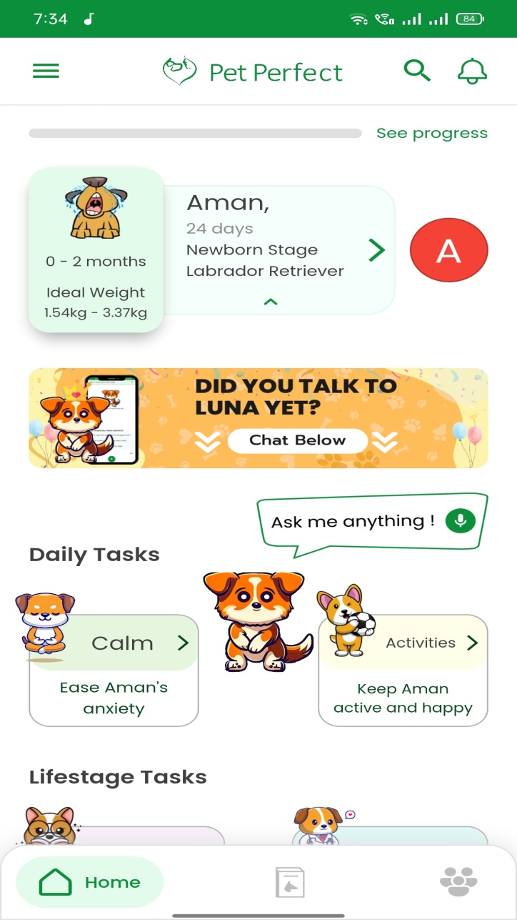

11

* **Petco: The Pet Parents Partner**

It’s basically a pet shop where people can buy all kinds of food and accessories for their pets. It also provides grooming and day boarding services. The app is more like a social media platform where people post videos, photos and other stuffs about their pet. The pet owner can interact with other pet owners and feel free to share their thoughts and can connect with each other.

**Cons:** More like a social media app and do not provide services in Nagpur.

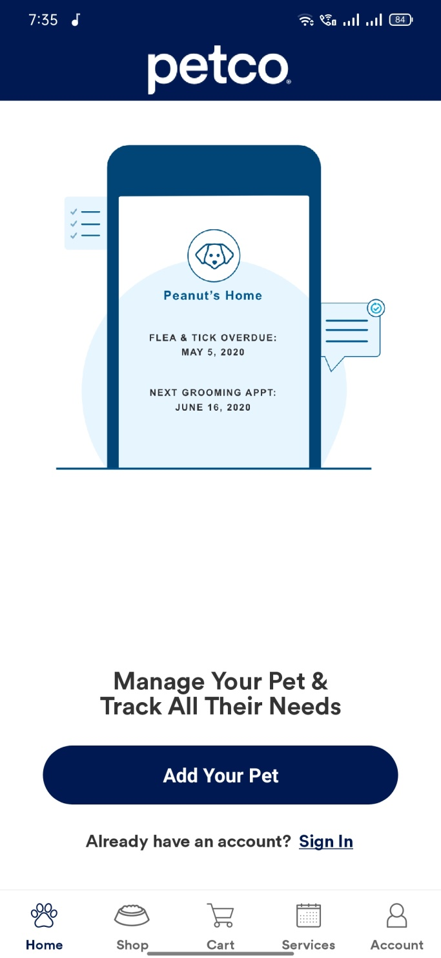

12

* **11 pets**

It is used to provide your pet information and can be kept for adoption where people can adopt pets. People can adopt pets and it also provides basic pet grooming services such as bath and saloon.

**Cons:** It mainly focuses on pet adoption.

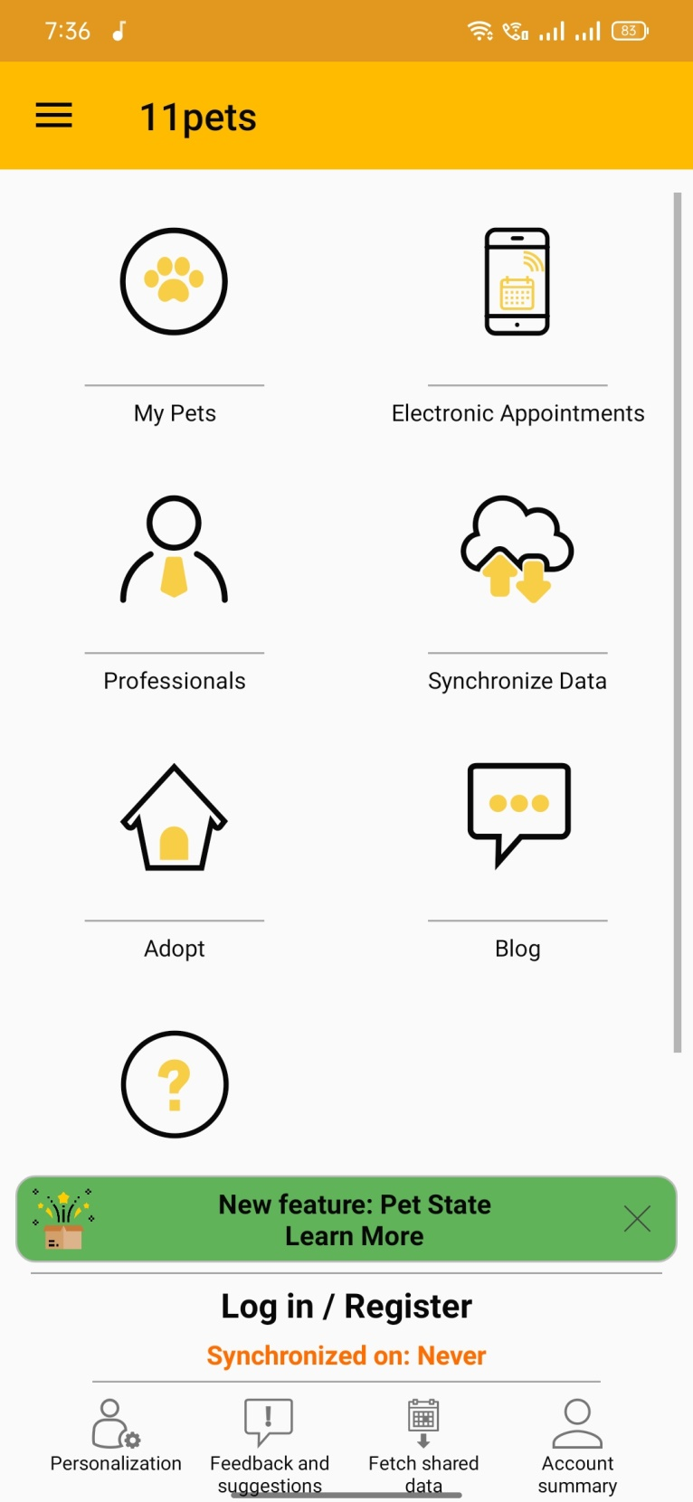

13

* **VitusVet: Pet Health Care App**

They are the providers of veterinary services. The application provides veterinary consultation and keeps the track of pet’s medical record.

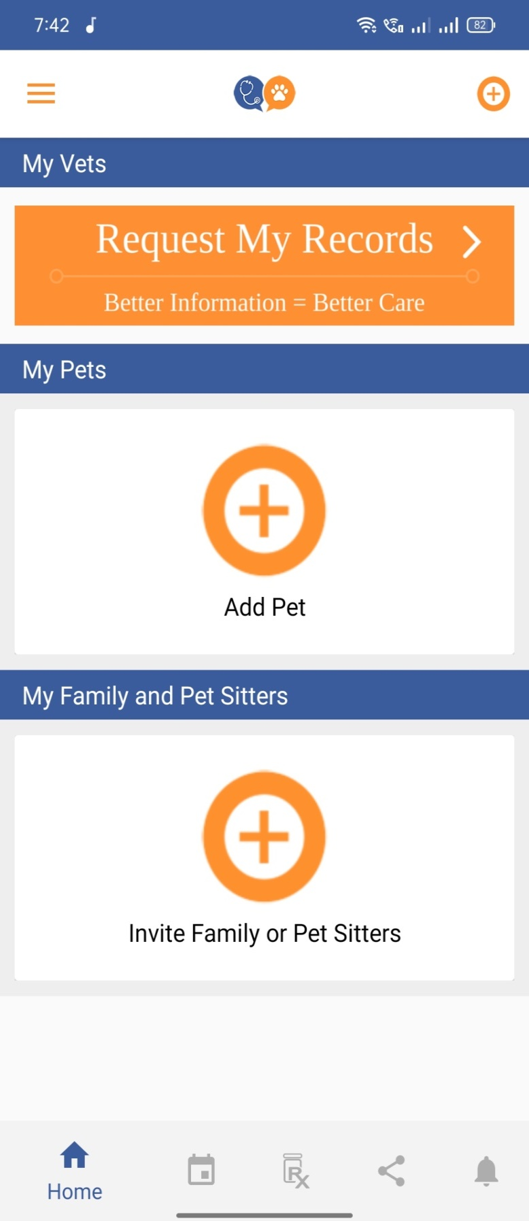

14

**2.3 Real Time Survey**

1. **Scoopy Scrub Nagpur:**

Scoopy Scrub located in Laxmi Nagar, Nagpur which provides pet grooming with a large variety of services. They provide services such as training, dog walkers, cat and dog grooming and styling, pet boarding, hair grooming, pet transportation, etc.

1. **Dogz Planet, Nagpur:**

Dogz planet located in Gokul Peth, Nagpur provides grooming, pet care, food and nutrition.

1. **Animal Health Care Centre, Nagpur:**

Animal Health Care Center located at Central Avenue Road, Nagpur provides animal treatment, consultation, pet vaccination and all kinds of pet accessories and food.

1. **Little Pet’s Paradise, Nagpur:**

Little Pet’s Paradise is located near Central Avenue Road, Nagpur provides grooming services for pets such as nail trimming, bathing, hair cutting, making pets groomed for pet shows, etc.

1. **Catbase grooming center, Nagpur:**

Catebase Grooming center is in Jaffar Nagar, Nagpur which only provides cat grooming and boarding services.

1. **Petazoo, Nagpur:**

Petazoo which is located in Trimurti Nagar, Nagpur provides various services for cats and dogs. They provide bathing, ear cleaning, nail trimming, flea and tick treatment, tooth brushing, body color and medical therapy.

1. **Vitsprecious pet solutions, Nagpur:**

15

Vitsprecious pet solutions located in Trimurti Nagar, Nagpur provides services such as day care, pet sitting, dog walking, pet food and they even sell various types of pets.

* Dr. Irshad Siddiqui’s pet clinic is located in Saoner, Nagpur. He provides veterinary services for all kinds of animals and provides their regular vaccinations, deworming, skin treatment, etc.
* Dr. Pramod Shinde’s pet clinic is in Mankapur, Nagpur. He provides various vet services such as regular vaccinations, surgery, radiology, dental and all kinds of medical treatment to animals.

**Problems Discussed:**

1. Customers want quality services for their pets because it is a matter of their pets health.
2. Customers need to visit more than one shop to find the type of services they need.
3. Sometimes customer wants services at their doorstep.
4. Sometimes the customers don’t know which kind of treatment is needed to their pet.

**Solutions Proposed:**

1. Customer will be easily able to find out all kinds of services provided by the service providers at a single place.
2. The customers having a hybrid lifestyle will not have to visit anywhere, they can get services at doorstep.
3. Customer can also check for vet services as well as the customer can order food for their pets.

16

**CHAPTER NO. 3**

**METHODOLOGY / PROPOSED SOLUTION**

**CHAPTER 3**

**METHODOLOGY / PROPOSED SOLUTION**

**3.1 PROPOSED WORK**

The intent of our project is that the user should get all types services for their pets which are provided by the various shops. The user should afford and compare prices of services provided by the shops across the city. The client must get all types of veterinary services used for the treatment of many kinds of diseases of their pets. Our marketplace will be simple where all the service providers will provide all kinds of services provided by them so that the customer can book them accordingly. Services such as grooming, training, day care, pet boarding and veterinary will be added by the providers.

Our application will be simple where the customer can book appointments with just login and payment. Our app will be user friendly. The principle of our app is to satisfy the customer with all his needs. We aim to get every person and their pet to connect with us.

**Modules:**

**Module 1: User /Customer**

Users are the people who have the access to see the services and products for their pets. The user has the access to buy various kinds of products for their pets as well as they can avail the services for them. We created the mobile application with the help of Ionic and Angular Framework.

1.1 **Home**: User/Customer can search for various kinds of products for their pets and, they can book appointment for vet as well as for grooming services.

1.2 **Order/Appointment Management**: Users/customers can view and process orders and pay for same also book an appointment for services.

1.3 **Customer Managements**: User/customer can Login/ log out, View/ Update Profile, give reviews about product as well as service.

17

**Module 2: Admin**

Admin panel is a backend area used to make a new entry of products and pets for adoption with some basic details. And also, can manage and access payment of the user. We used SQLITE as database to store our data.

2.1 **Admin Dashboard**: Admin can see all records of the products, services and orders.

2.2 **Manage Products**: Admin can Add/update and delete products as well as pets and services.

2.3 **Admin Management**: Admin can Login/ Log out.

18

**3.2 SYSTEM ARCHITECTURE**

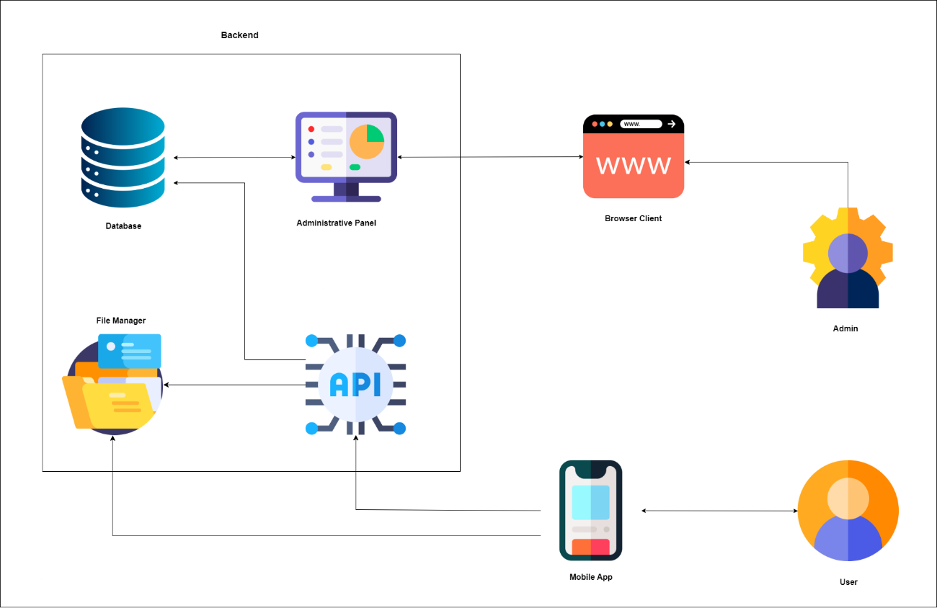

**Fig 3.2 System Architecture**

The primary focus of the application is to provide all kinds of services and pet food according to the users’ need. We achieved this by creating different modules for the project. The users just have to Login/Signup their accounts to buy food and book services. After buying or booking the user can pay online by card or by cash.

The above architecture describes the complete view of the app and its usage in the perfect manner. It also shows the work of all the actors.

**3.3 SYSTEM FLOW CHART**

19

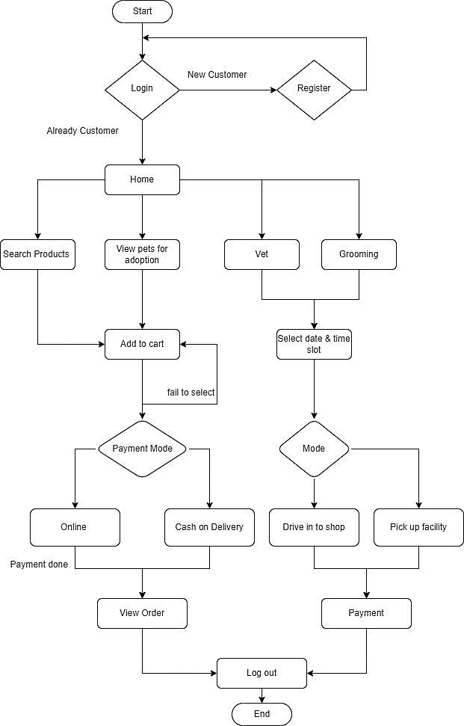

**Fig 3.3 System Flow Chart**

Here, we have shown the flow of our project. In this you can find the Login/Signup of the Customer as well as the Admin. The customer/ admin has to give valid credentials because they have to verify their account using email verification/ mobile number verification. If already have an account, the customer/admin can directly login otherwise they need to signup first. After successful login the customer can view products and book services. Then after selecting the customer can buy and add the product to its cart. After which he needs to pay online by card or by UPI. After that he can log out. After successful login of admin, the admin can manage orders by adding, deleting products, accepting/ rejecting bookings. Admin can also check feedback.

20

**CHAPTER NO. 4**

**TOOLS / PLATFORM**

**CHAPTER 4**

**TOOLS / PLATFORM**

**4.1 SOFTWARE REQUIREMENT**

1. **Operating System**: Windows 7 or Higher

2. **Web Framework**: Ionic Framework

3. **Server-Side Technology**: PHP, CodeIgniter

4. **Client-Side Technology**: Ionic, Angular Framework

5**. Database:** MySQL

6. **Designing Tool**: Draw.io

7. **Libraries Used**: Stripe

**1. OPERATING SYSTEM:**

Any Operating System (preferably windows 7 or higher) which has architecture of 32-bit or higher is supported. We have used Windows 10 64-bit.

**2. WEB FRAMEWORK:**

**Ionic Framework -**

Ionic is freely available, open-source, and a front-end SDK framework that enables you to create mobile-based applications for iOS, Windows, and Android phones using the same codebase. It proves to be a cross-platform tool for mobile development. This tool allows you to create hybrid mobile applications. This platform enables you to build mobile apps with the help of web applications and languages like HTML, CSS, JavaScript, Angular, and Typescript. Ionic has a collection of components that provides the functionality of a mobile platform. Except for the feature, Ionic provides different behaviors. Ionic comes with efficient performance with minimum DOM manipulation. It comes with its command-line interface that allows you to develop the application and saves the coding efforts.

21

**Features:**

* **Platform Independent Framework**

Ionic can work irrespective of what platform you are using to provide a native look and feel. There is no need to change the code as it works on mobile-optimized web components. Ionic works with Angular to provide a robust structure, which in turn reduces the cost.

* **Cross-Platform Mobile Application Development**

There are a variety of mobiles with different operating systems. If we are developing any mobile application, then it should be compatible with different operating systems. Ionic has the same codebase that allows developers to create applications that work for all mobile devices to provide you with a unified feel and look.

* **Shows High Performance**

Ionic provides a friendly environment to create applications that will run on mobile devices. You can use any component to speed up mobile performance.

* **Helps in Creating Elegant Designs**

With the help of Ionic framework, developers will be able to create robust and simple designs. Ionic provides you with simple customizable themes and components that will provide a great user interface and attract more people to your application.

**Disadvantages:**

* The performance of the Ionic application is not as good as compared to native mobile applications. However, the performance gap is not noticeable for most of the average users.
* The app developed with the Ionic framework may not provide as much security as a native application. For example, if you are developing a financial app, e.g., the app for a bank, the Ionic framework is not recommended.
* There are some native functions that may not be available in the Ionic framework. In such a case, you need to develop the plugin to fulfill that function yourself. However, there are many plugins available to cover most of the native functionalities.

22

* Ionic framework is not perfect for high-end graphics-dependent applications or video games.

**3.** **SERVER-SIDE TECHNOLOGY:**

* **PHP**

The name PHP stands for Hypertext Preprocessor and denotes a server-side scripting language, which suggests that applications are written thereon run on web servers and don’t depend upon the online browser. The syntax of PHP language is analogous to C language. PHP is being widely utilized in developing web applications and has become one of the main languages for developers to make new applications. Leading social networking sites like Facebook and reputed organizations like Harvard University are both using PHP which makes it popular and increases its credibility.

**Features:**

1. **Open Source and Free of Cost**

One of the most vital advantages of PHP is that it is accessible to all. One can download it anywhere and readily use it for web application development.

###### Platform Independence

Another important factor is that PHP applications can run on any OS such as UNIX, Windows, Linux etc. People can use it without worrying about the platform where one can use it.

###### Easy Loading

One can load PHP-based applications easily and connect to the database. People mainly use it since it has a faster rate of loading even if it is slow internet connection and speed than other programming languages.

1. **User-Friendly**

It has a less learning curve, and one can learn it quickly. The language is straight forward to use, and if one knows C programming, they can catch PHP quickly.

23

**Disadvantages:**

1. It is not that secure due to its open source, because the ASCII text file is easily available.
2. It is not suitable for giant content-based web-applications.
3. It has a weak type, which can cause incorrect data and knowledge to the user.
4. PHP frameworks got to learn to use PHP built-in functions to avoid writing additional code.
5. PHP does not allow change or modification in the core behaviour of online applications.

* **CodeIgniter**

CodeIgniter is a PHP driven framework but it's not a PHP substitute. Diving into CodeIgniter doesn’t mean you are leaving PHP behind. PHP is a server-side scripting language for building dynamic web-based applications.

CodeIgniter contains libraries, a simple interface, and logical structure to access these libraries, plug-ins, helpers, and some other resources which solve the complex functions of PHP more easily maintaining a high performance. It simplifies the PHP code and brings out a fully interactive, dynamic website in a much shorter time. It supports PHP version of 5.2.6 or newer and MySQL version 4.1 or newer. It makes your web more robust and your code easier to read and maintain. It is a free toolkit, light weight and easier to install.

**Features:**

* **Small footprint:**

The entire source code for CodeIgniter framework is close to 2MB. This makes it easy to master CodeIgniter and how it works. It also simplifies deploying and updating it.

24

* **Blazing fast:**

Users tend to favor applications that load very fast. If you have worked with some of the modern frameworks, then you will realize that they take less than one second to load just after installation. CodeIgniter, you can load on average around less than 50ms. The extra time spent optimizing, as is the case in another framework is freed up when you are working with CodeIgniter framework.

* **Loosely coupled:**

The built-in features are designed to work independently without relying too much on other components. This makes it easy to maintain and make upgrades.

* **MVC Architecture:**

The PHP CodeIgniter framework uses the Model-View-Controller architectural design. It is an industry standard practice when working with web applications. MVC separates the data, business logic, and presentation.

* **Excellent documentation:**

The framework is well documented, and there are good books, tutorials and answered forum questions on CodeIgniter. This means whatever challenge that you have, chances are someone has already encountered the problem, solved it and the solution is out there for you.

**Disadvantages:**

* The enterprises require programmers to write clean, readable, and structured code. The high-quality code makes it easier for enterprises to maintain, modify, and update web applications quickly in the future. CodeIgniter does not support the modular separation of code by default.
* CodeIgniter stimulates custom web application development by implementing several libraries. It will allow developers to install only the libraries required by the web application. The programmers can also increase and customize the primary libraries easily by extending the native classes.

25

**4. CLIENT-SIDE TECHNOLOGY:**

**Angular Framework -**

Angular is an open-source, JavaScript framework written in TypeScript. Google maintains it, and its primary purpose is to develop single-page applications. As a framework, Angular has clear advantages while also providing a standard structure for developers to work with. It enables users to create large applications in a maintainable manner.

**Features:**

* **Two-way Data Binding:**

Two-way data binding in Angular will help users to exchange data from the component to view and from view to the component. It will help users to establish communication bi-directionally. Two-way data binding can be achieved using a ngModel directive in Angular. This ensures that the model and the view are always kept in sync without any extra effort.

* **Use of TypeScript:**

Angular opted for TypeScript as the primary programming language. TypeScript adds a lot of syntactic sugar to JavaScript. With TypeScript, we also get several productivity benefits. In editors like VS Code and WebStorm, we have access to robust code help (intellisense) as we type, making it easier to discover types, the features they offer, and most importantly the common syntactical errors.

* **Dependency Injection:**

Dependency injection or DI is one of the most important application design patterns and Angular has its own dependency injection framework. It is typically used in the design of Angular applications to increase their efficiency and modularity. This is closely related to the previous point - modularization of the Angular app.

* **Support for Ionic:**

Angular was the first framework that was supported by the Ionic framework. It allows building cross-platform mobile applications for Android and iOS using the Ionic components and Angular code.

26

As of now, more frameworks like ReactJS and VueJS are also supported but still, Angular is widely used with the Ionic framework for mobile application development.

**Disadvantages:**

* **Limited SEO Capabilities:**

Angular is just great for building powerful single-page web applications. However, as with all single-page web applications, there is a disadvantage when it comes to search engine optimization.

* **Too many versions:**

Angular has been evolving. It started out as a JavaScript framework AngularJS and now the current version is Angular 9 with a total of 6 major releases in between. This can cause confusion especially for beginners.

* **Steeper learning curve:**

While Angular is great, it may not be the case for a complete beginner. Even if you have experience with HTML, CSS and JS, you may feel a little bit uncomfortable with the steep learning curve that it has. It brings its own notions and philosophy to the table that you need to work around.

* **Lot of boilerplate code:**

If you are building a simple app, there is a lot of boilerplate code that the application requires. Although with tools like Stack Blitz, it has become easier to try code ideas and experiment without having to install anything on your computer, but if you decide to start developing an Angular app on your system, you need to install a bunch of things and the simplest “Hello World!” application will have a lot of code that you do not care about.

**5. DATABASE:**

**MYSQL -**

MySQL is currently the most popular database management system software used for managing the relational database. It is open-source database software, which is supported by Oracle Company. It is fast, scalable, and easy to use database management system in comparison with Microsoft SQL Server and Oracle Database. It is commonly used in conjunction with PHP scripts for creating powerful and dynamic server-side or web-based enterprise applications.

27

**Features:**

* MySQL is a Relational Database Management System or RDBMS which means that it stores and presents data in tabular form, organized in rows and columns.
* MySQL is more secure as it consists of a solid data security layer to protect sensitive data from intruders and passwords in MySQL are encrypted.
* MySQL is available for free to download and use from the official site of MySQL.
* MySQL is compatible with most of the operating systems, including Windows, Linux, NetWare, Novell, Solaris and other variations of UNIX.
* MySQL provides the facility to run the clients and the server on the same computer or on different computers, via internet or local network.
* MySQL has a unique storage engine architecture which makes it faster, cheaper and more reliable.

**Disadvantages:**

* MySQL is not very efficient in handling very large databases.
* MySQL doesn’t have as good a developing and debugging tool as compared to paid databases.
* MySQL versions less than 5.0 do not support COMMIT, stored procedure and ROLE.
* MySQL is prone to data corruption as it inefficient in handling transactions.

**6**. **DESIGNING TOOL:**

**Draw.io -**

Draw.io is completely free online diagram editor built around Google Drive (TM) that enables you to create flowcharts, UML, entity relation, network diagrams, mock-ups and more.

28

**Features:**

• Collaboration Tools

• Data Import/Export

• Drag & Drop Interface

• Third Party Integration

**7. LIBRARIES USED:**

**Stripe -**

Stripe is a server-side helper library also known as Server-side SDKs is used to reduce the amount of work required to use stripe’s REST APIs, starting with reducing the boilerplate code you must write. Millions of companies from startups to fortune 500s uses stripes software and APIs to accept payments, sent payouts, and manage their businesses online.

**4.2 HARDWARE REQUIREMENT**

* **Android Version:** 8 or above.
* **Requirement:** Internet Connection
* **Ram:** Minimum 2 GB

29

**CHAPTER NO. 5**

**DESIGN & IMPLEMENTATION**

**CHAPTER 5**

**DESIGN & IMPLEMENTATION**

**5.1 SYSTEM DESIGN**

**5.1.1 USE-CASE DIAGRAM**

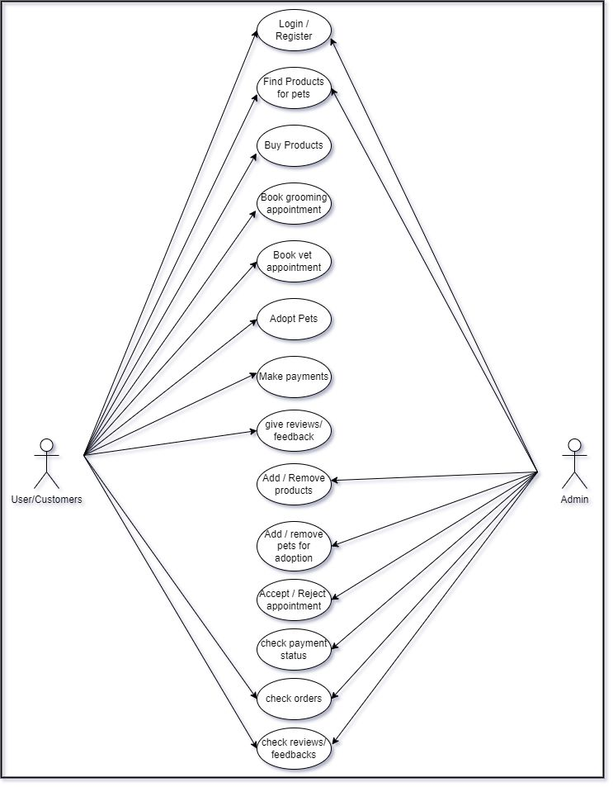

**Fig 5.1.1 Use-Case Diagram**

30

The above use case diagram depicts the task which a customer can perform through our application. The customer can register/login into the application. The user/customer can view and search for various services from the shop list. After which the user/customer can add the products/ services to cart and pay online using net banking, card, or cash. After that the user/customer can logout.

The admin registers/login as same as the user then they can manage products by adding or deleting orders and by accepting or deleting bookings. The admin can manage bookings and products.

31

**5.1.2 CLASS DIAGRAM**

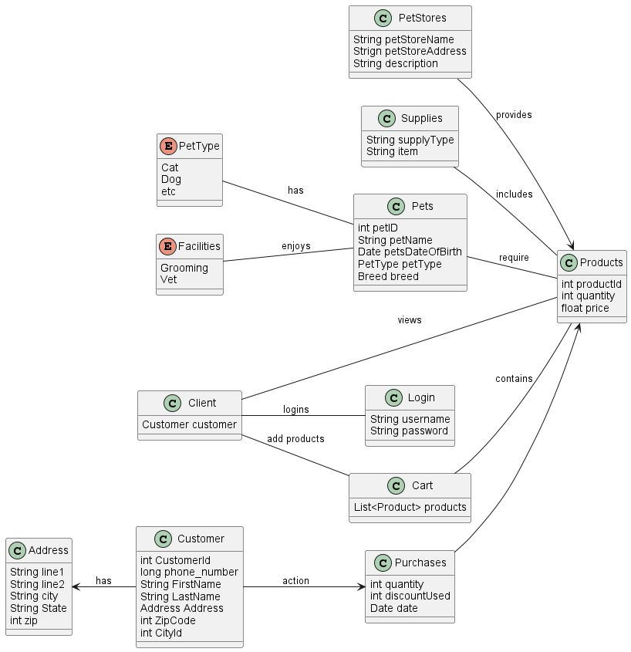

**Fig 5.1.2 Class Diagram**

In the above class diagram, the whole working of our application is representedina certain manner. The customer class is responsible for registration and validation of login info as well. The customer class is also responsible for viewing and buying products as well as book services. The admin class is responsible for registration/ login and managing products and booking functions. Product class shows the products with id price, quantity, and image function. Payment class is responsible for the payments by the customer.

32

**5.1.3 SEQUENCE DIAGRAM**

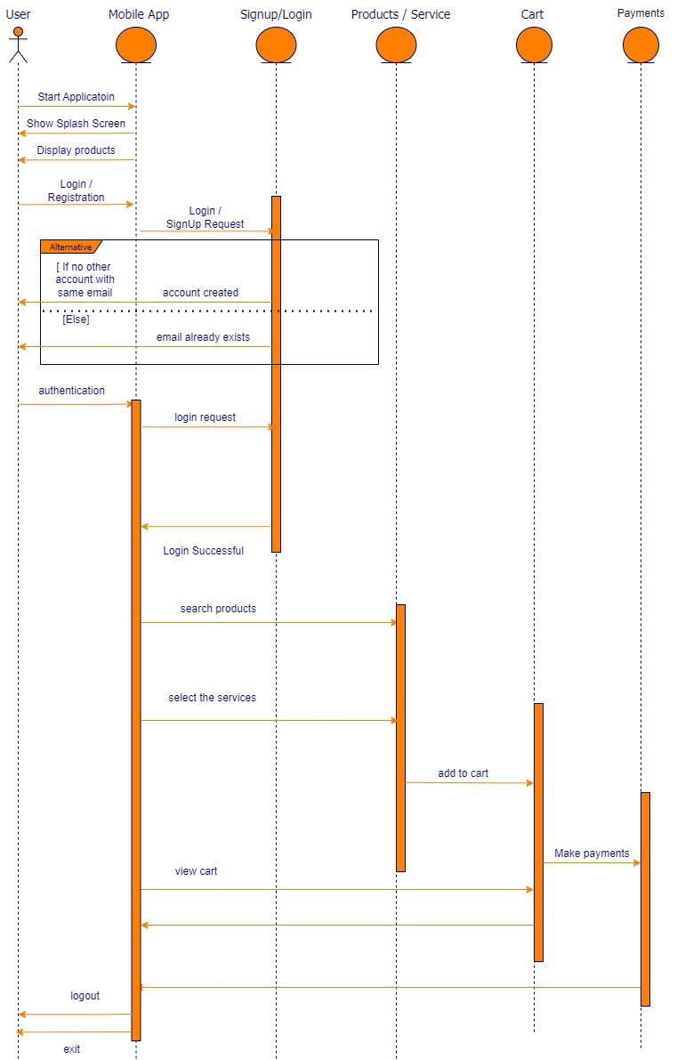

**Fig 5.1.3 Sequence Diagram**

33

* **Mobile App:** After landing on the application and verifying, user is free to browse the application and check the products and services listed in different shops.
* **Signup / Login:** After successful login the customer can get the product list and information and can buy products and book services and then pay online by net banking, card, or cash.
* **Product / Services:** The product will show the products list with unique id, quantity, and price. It gives product information and payment methods.
* **Cart:** The user can check the cart and proceed to payments.
* **Payments:** The customer can pay by card or can pay cash on delivery.

34

**5.2 IMPLEMENTATION OF SYSTEM**

**5.2.1 Implemented Modules**

We have completed the creation of the user as well as our admin module. We collected data of services from various applications. We have completed GUI designing.

**Module 1: User /Customer**

Users are the people who have the access to see the services and products for their pets. The user has the access to buy various kinds of products for their pets as well as they can avail the services for them. We created the mobile application with the help of Ionic and Angular Framework.

1.1 **Home**: User/Customer can search for various kinds of products for their pets and, they can book appointments for vet as well as for grooming services.

1.2 **Order/Appointment Management**: Users/customers can view and process orders and pay for same also book an appointment for services.

1.3 **Customer Managements**: User/customer can Login/ log out, View/ Update Profile.

**Module 2: Admin**

Admin panel is a backend area used to make a new entry of products and pets for adoption with some basic details. And can manage and access payment of the user. We used SQLITE as a database to store our data.

2.1 **Admin Dashboard**: Admin can see all records of the products, services, and orders.

2.2 **Manage Products**: Admin can Add/update and delete products as well as pets and services.

2.3 **Admin Management**: Admin can Login/ Log out.

35

**5.2.2 SAMPLE CODE**

**Login.page.ts**

import { Component, OnInit } from '@angular/core';  
import { ApiService } from 'src/Providers/Services/api.service';  
import { MenuController, AlertController, ModalController } from '@ionic/angular';  
import { BasicApiService } from 'src/Providers/Basic/basic-api.service';  
import { LocalApiService } from 'src/Providers/Local/local-api.service';  
import { Router, ActivatedRoute } from '@angular/router';  
import { Location } from "@angular/common";  
import * as $ from 'jquery';  
import { CartApiService } from 'src/Providers/Cart/cart-api.service';  
import { Device } from '@ionic-native/device/ngx';  
import { TouchID } from '@ionic-native/touch-id/ngx';  
import { environment } from '../../environments/environment';  
  
@Component({  
 selector: 'app-login',  
 templateUrl: './login.page.html',  
 styleUrls: ['./login.page.scss'],  
})  
export class LoginPage implements OnInit {  
 logmobile: any;  
 postdata: any = {};  
 tknsvdata: any = {};  
 isnewUser: any = false;  
 regt: any = {};  
 logedpass: any;  
 isPassrd: any = false;  
 mytoken: any;  
 logedUser: any;  
 isTouchidDevice: any = false;  
 isdeviceuser: any;  
 isshowfldsnup: any = true;  
 isTncdesc: any = false;  
 ispvcdesc: any = false;  
 allProducts: any;  
 adnmregdata: any;  
 isWallert: any = false;  
 getappsetng: any;  
 constructor(  
 public menuCtrl: MenuController,  
 public apiService: ApiService,  
 public basic: BasicApiService,  
 public localApi: LocalApiService,  
 public cart: CartApiService,  
 public route: Router,  
 public alertController: AlertController,  
 public location: Location,  
 public modalController: ModalController,  
 private activatedRoute: ActivatedRoute,  
 private device: Device,  
 private touchId: TouchID  
 ) { }  
 ngOnInit() {  
 this.isdeviceuser = this.localApi.getuserdevice();  
 this.getappsetng = this.localApi.getappseting();  
 if (this.getappsetng.wallet == 'YES') {  
 this.isWallert = true;  
 }  
 this.touchId.isAvailable().then(res => {  
 if (this.isdeviceuser) {  
 this.openTouchid();  
 }  
 }, err => {  
 console.error('TouchID is not available', err)  
 });  
 }  
 gotncpg(val) {  
 this.postdata.pgtype = val;  
 this.basic.presentLoading();  
 this.apiService.postdata('getallcms', this.postdata).subscribe((resp: any) => {  
 this.allProducts = resp.data;  
 console.log(this.allProducts);  
 setTimeout(() => {  
 this.basic.dismissloader();  
 this.isshowfldsnup = false;  
 this.isTncdesc = true;  
 }, 1000)  
 }, (err: any) => {  
 return false;  
 });  
 }  
 closetncpvc() {  
 this.isshowfldsnup = true;  
 this.isTncdesc = false;  
 }  
 openTouchid() {  
 this.touchId.verifyFingerprint('Scan your fingerprint please').then(res => {  
 this.isdeviceuser = this.localApi.getuserdevice();  
 console.log('Ok', res);  
 this.localApi.setuser(this.isdeviceuser);  
 this.setUserTokens();  
 this.dismissmodal();  
 }, err => {  
 console.error('Error', err);  
 });  
 }  
 checkMobile() {  
 this.adnmregdata = '';  
 var str = this.logmobile;  
 var res = str.substring(0, 2);  
 if (!this.logmobile) {  
 this.basic.alert('Error:', 'Enter your registered mobile number');  
 } else if (this.logmobile.length < 10) {  
 this.basic.alert('Error:', 'Please enter a valid mobile number');  
 } else {  
 this.basic.presentLoading();  
 this.postdata.mobile = this.logmobile;  
 this.apiService.postdata('checllogin', this.postdata).subscribe((resp: any) => {  
 console.log('DDssss', resp);  
 if (resp.data == false) {  
 this.isnewUser = true;  
 } else {  
 if (resp.data.device == 'ADMIN') {  
 this.adnmregdata = resp.data;  
 // this.regt.fullname = resp.data.name;  
 this.isnewUser = true;  
 } else {  
 this.isPassrd = true;  
 }  
 }  
 setTimeout(() => {  
 this.basic.dismissloader();  
 }, 1000)  
 }, (err: any) => {  
 return false;  
 });  
 }  
 }  
 loginnow() {  
 if (!this.logedpass) {  
 this.basic.alert('Error:', 'Enter your password');  
 } else {  
 this.basic.presentLoading();  
 this.postdata.mobile = this.logmobile;  
 this.postdata.password = this.logedpass;  
 this.apiService.postdata('login', this.postdata).subscribe((resp: any) => {  
 if (resp.data == false) {  
 this.basic.alert('Error:', 'Password did not match!');  
 } else {  
 this.localApi.setuser(resp.data);  
 // this.appcmp.callog();  
 this.setUserTokens();  
 this.dismissmodal();  
 }  
 setTimeout(() => {  
 this.basic.dismissloader();  
 }, 1000)  
 }, (err: any) => {  
 return false;  
 });  
 }  
 }  
 setUserTokens() {  
 this.mytoken = localStorage.getItem(environment.storage_prefix + 'userdevicetoken');  
 this.logedUser = this.localApi.getuser();  
 this.tknsvdata.token = this.mytoken;  
 this.tknsvdata.device = 'Mobile';  
 this.tknsvdata.device_type = this.device.platform;  
 this.tknsvdata.user = 'Customer';  
 this.tknsvdata.user_id = this.logedUser.id;  
 this.apiService.postdata('setusertokens', this.tknsvdata).subscribe((resp: any) => {  
 console.log('Set Token', resp)  
 }, (err: any) => {  
 return false;  
 });  
 }  
 signupnow() {  
 this.mytoken = localStorage.getItem(environment.storage_prefix + 'userdevicetoken');  
 var re = /^(([^<>()[\]\\.,;:\s@\"]+(\.[^<>()[\]\\.,;:\s@\"]+)*)|(\".+\"))@((\[[0-9]{1,3}\.[0-9]{1,3}\.[0-9]{1,3}\.[0-9]{1,3}\])|(([a-zA-Z\-0-9]+\.)+[a-zA-Z]{2,}))$/;  
  
 if (!this.regt.fullname) {  
 this.basic.alert('Error:', 'Enter your full name');  
 } else if (!this.regt.email) {  
 this.basic.alert('Error:', 'Enter your email address (for recover your password)');  
 } else if (!re.test(this.regt.email)) {  
 this.basic.alert('Error:', 'Please enter a valid email');  
 } else if (!this.regt.password) {  
 this.basic.alert('Error:', 'Enter a password');  
 } else {  
 this.postdata.mobile = this.logmobile;  
 this.postdata.otherdetails = this.regt;  
 this.basic.presentLoading();  
 this.postdata.mobile = this.logmobile;  
  
 this.postdata.token = this.mytoken;  
 this.postdata.device = 'Mobile';  
 this.postdata.device_type = this.device.platform;  
  
 this.postdata.adnmregdata = this.adnmregdata;  
 if (this.adnmregdata) {  
 this.postdata.isupd = 'OLD';  
 } else {  
 this.postdata.isupd = 'NEW';  
 }

36

37

38

39

40

41

**CHAPTER NO. 6**

# **TESTING, RESULTS & DISCUSSION**

##### **CHAPTER 6**

**TESTING, RESULTS & DISCUSSION**

**6.1 TESTING**

**6.1.1 TYPES OF TESTING**

**Manual Testing**

Manual testing includes testing software manually, i.e., without using any automated tool or any script. In this type, the tester takes over the role of an end-user and tests the software to identify any unexpected behavior or bug. There are different stages for manual testing such as unit testing, integration testing, system testing, and user acceptance testing.

Testers use test plans, test cases, or test scenarios to test software to ensure the completeness of testing. Manual testing also includes exploratory testing, as testers explore the software to identify errors in it.

Following are the testing techniques that are performed manually during the test life Cycle:

* Acceptance Testing
* White Box Testing
* Black Box Testing
* Unit Testing
* System Testing
* Integration Testing

42

**Automation Testing**

Automation testing, which is also known as Test Automation, is when the tester writes scripts and uses software to test the product. This process involves automation of a manual process. Automation Testing is used to re-run the test scenarios that were performed manually, quickly, and repeatedly.

Apart from regression testing, automation testing is also used to test the application from load, performance, and stress point of view. It increases the test coverage, improves accuracy, and saves time and money in comparison to manual testing.

Test Automation should be used by considering the following aspects of a software:

* Large and critical projects
* Projects that require testing the same areas frequently
* Requirements not changing frequently.
* Accessing the application for load and performance with many virtual users
* Stable software with respect to manual testing
* Availability of time

43

* + 1. **LEVELS OF TESTING**

There are four levels of testing: Unit, Integration, System and Acceptance.

1. **Unit Testing:** A level of the software testing process where individual units/components of a software/system are tested. The purpose is to validate that each unit of the software performs as designed.
2. **Integration Testing**: A level of the software testing process where individual units are combined and tested as a group. The purpose of this level of testing is to expose faults in the interaction between integrated units.
3. **System Testing:** A level of the software testing process where a complete, integrated system/software is tested. The purpose of this test is to evaluate the system’s compliance with the specified requirements.
4. **Acceptance Testing**: A level of the software testing process where a system is tested for acceptability. The purpose of this test is to evaluate the system’s compliance with the business requirements and assess whether it is acceptable for delivery.

44

* + 1. **TESTING REPORT**

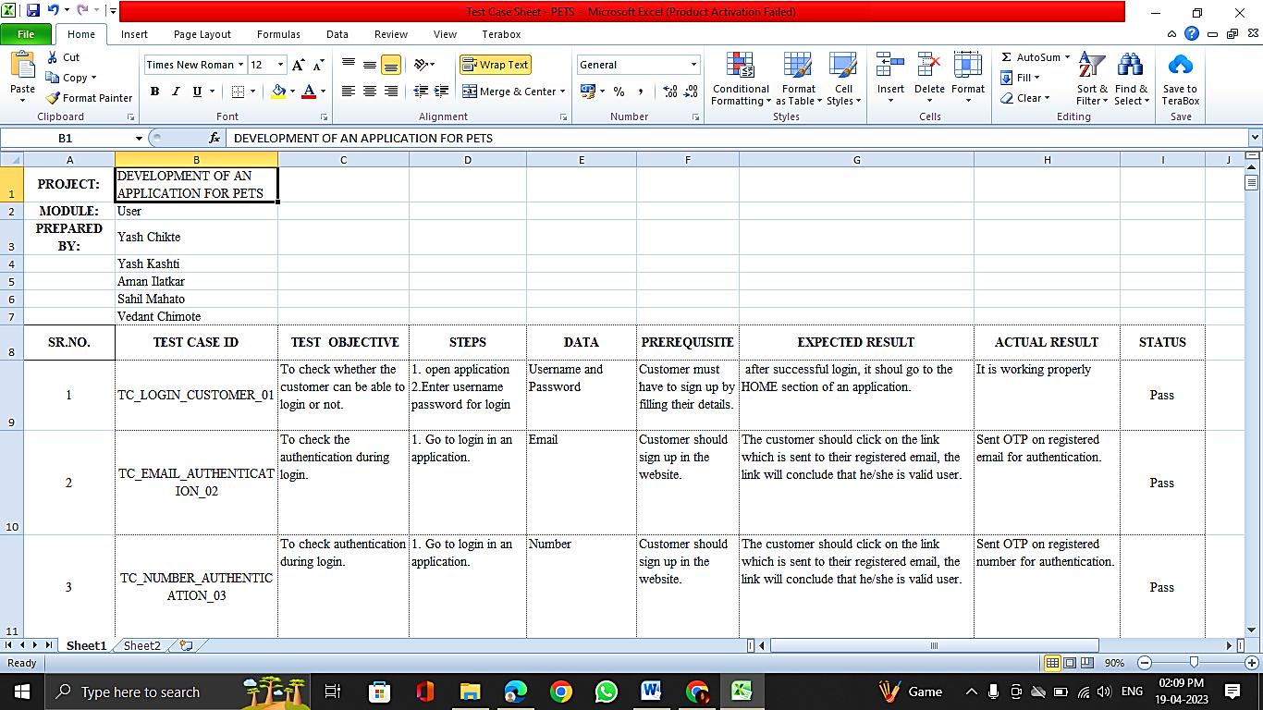

45

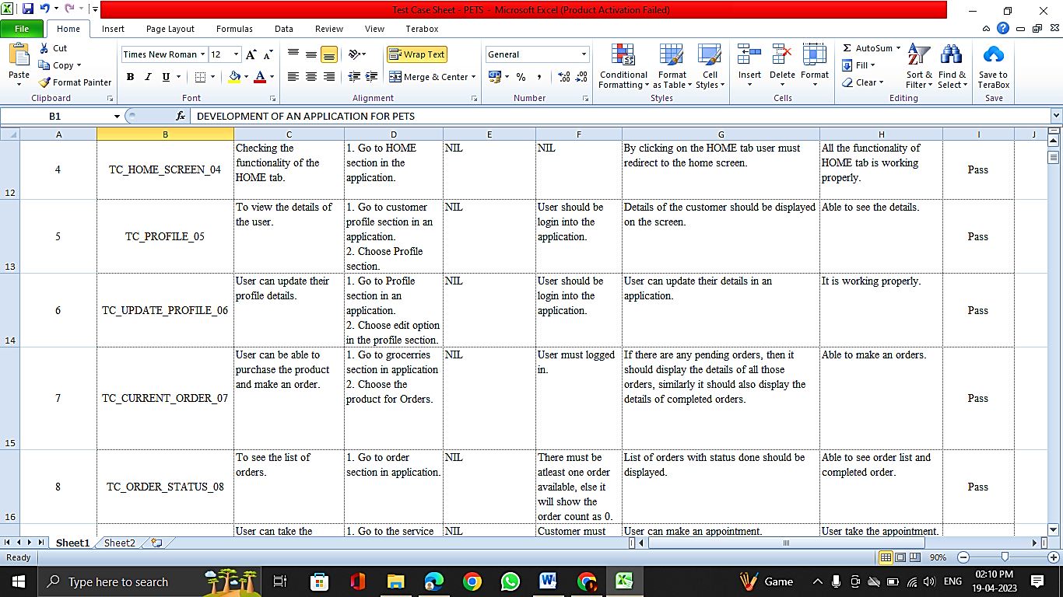

46

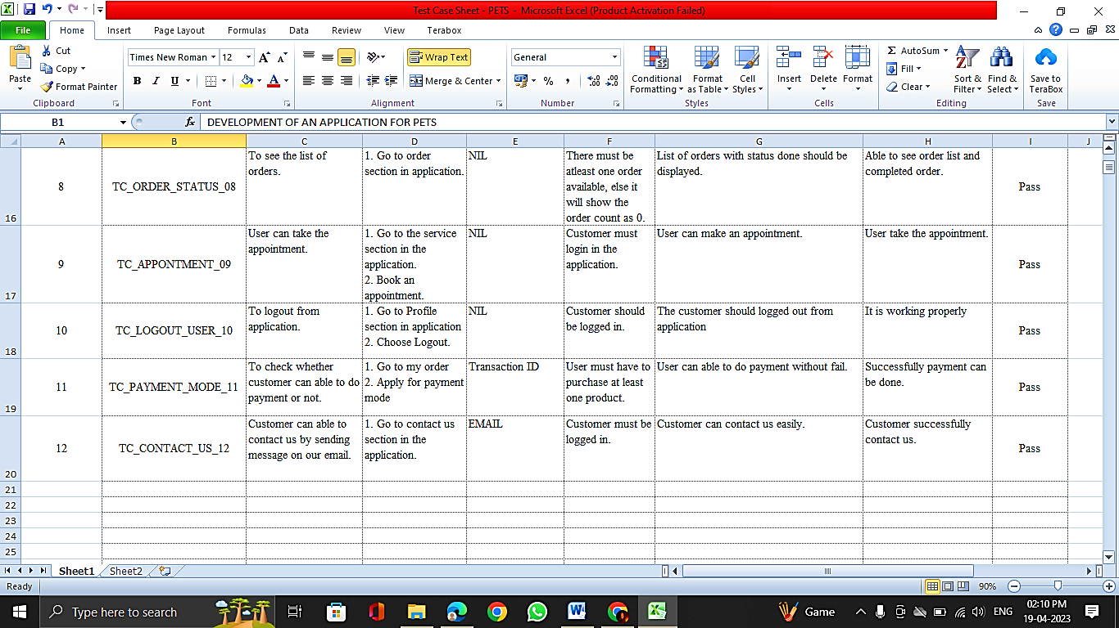

47

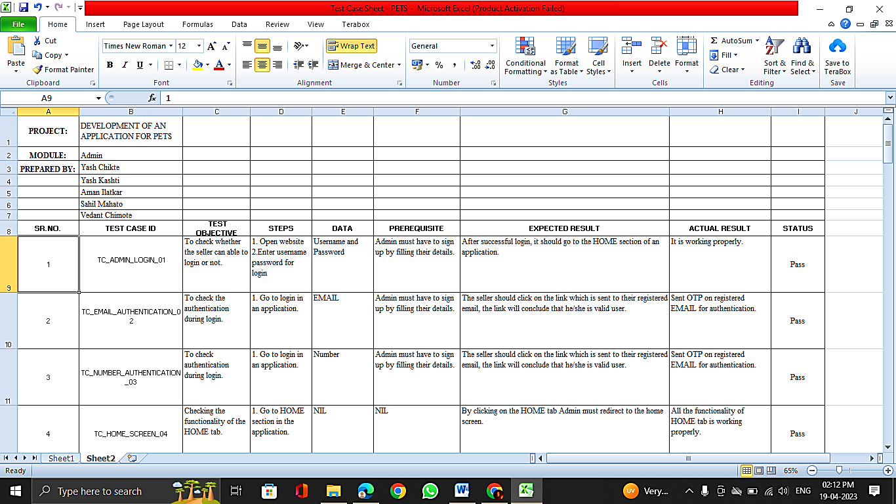

48

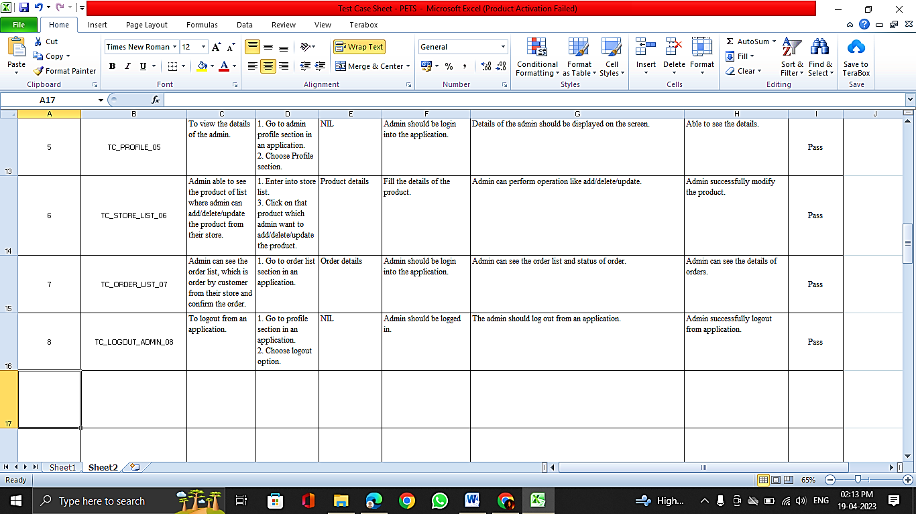

49

**6.2 RESULTS AND DISCUSSION**

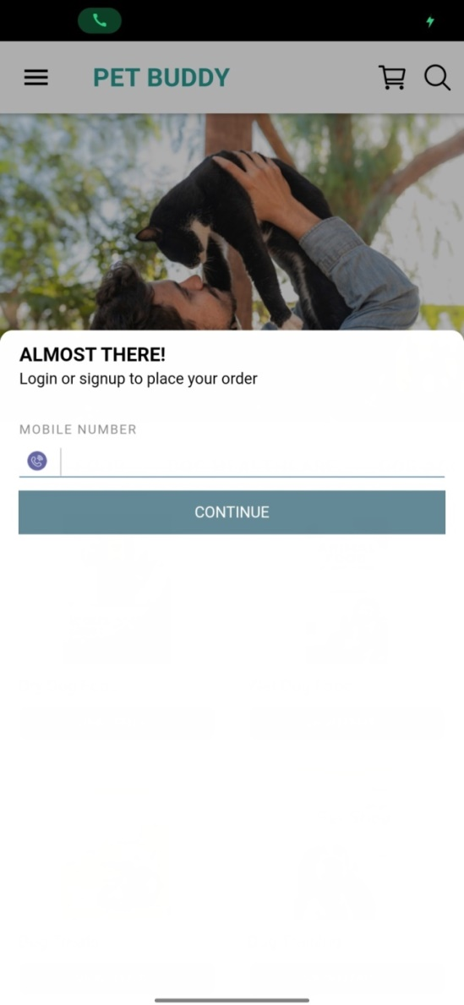

**Fig. 6.2.1 Customer Signup**

Firstly, the customer needs to sign up by entering proper information.

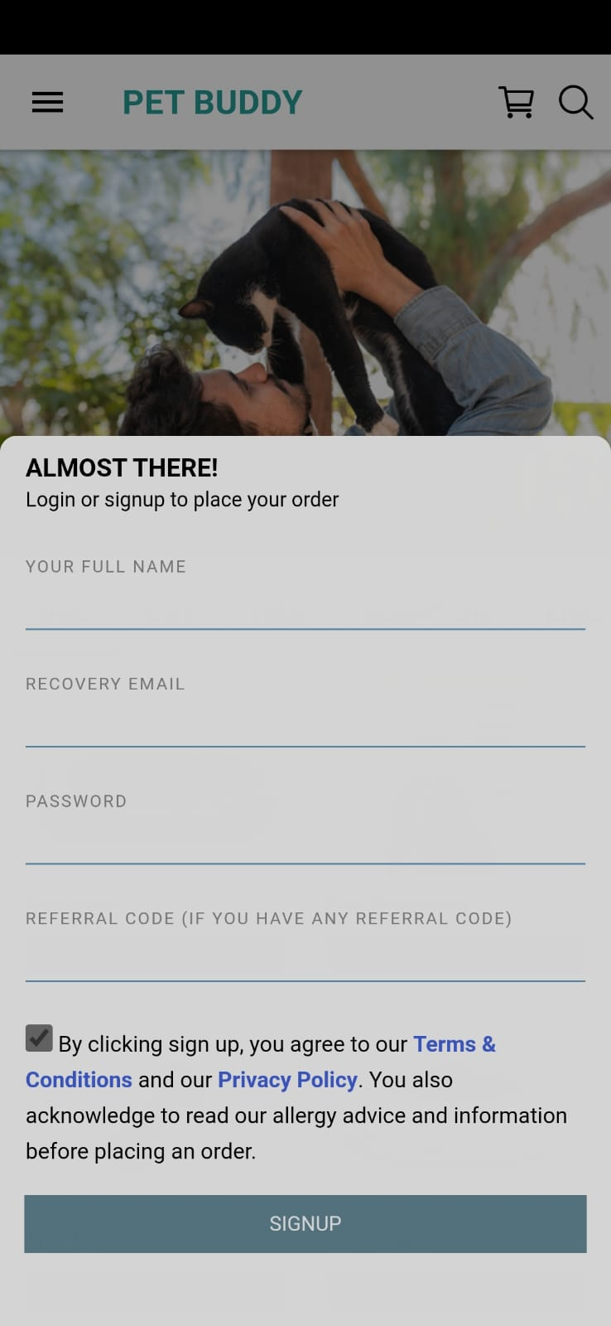

**Fig. 6.2.2 Login Page**

The customer can login by giving full details after Signup.

50

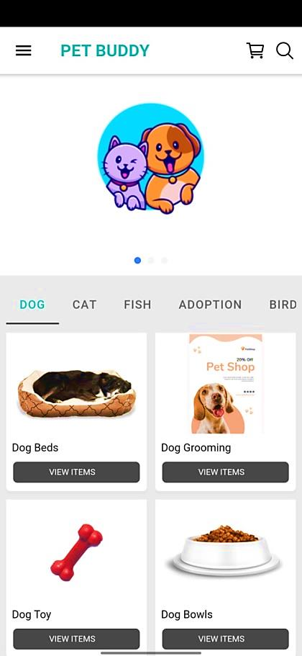

**Fig. 6.2.3 Home Page**

This is the Home Screen of our Application. Here users will see the products for various pets. Users can also see the products list. Users will see Login/Register tab on the home screen. The interface of our application is very user friendly. User will have to Login/Register first

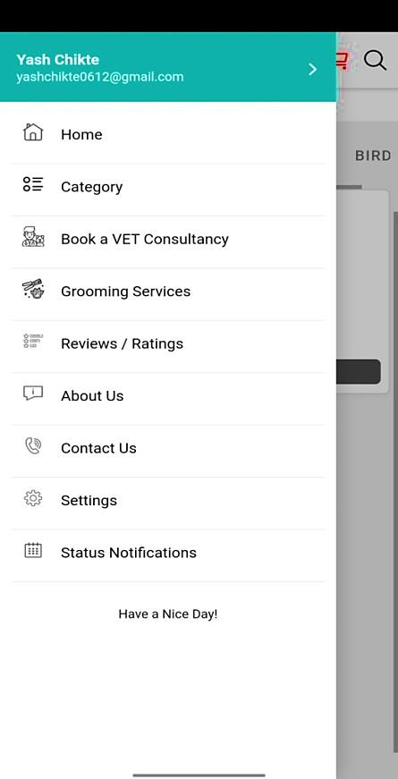

**Fig. 6.2.4 Services List**

In this section the user can see the various services in the application provided by the admin.

51

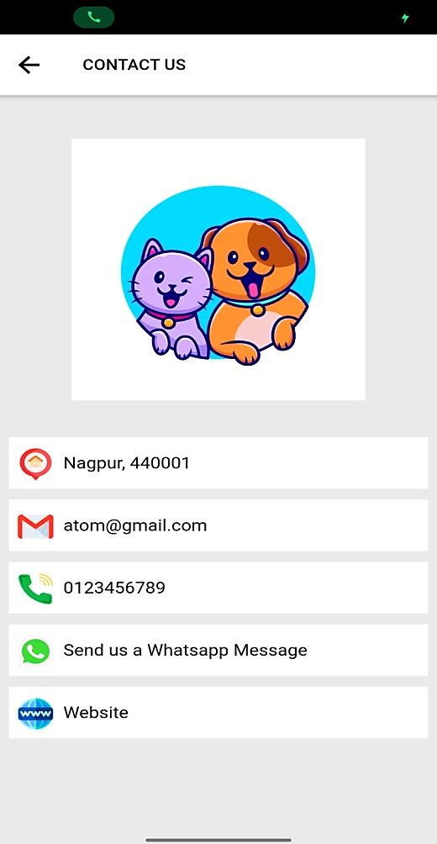

**Fig. 6.2.5 Contact Us**

This is our Contact Us page from where the user can contact us through email, call, or WhatsApp.

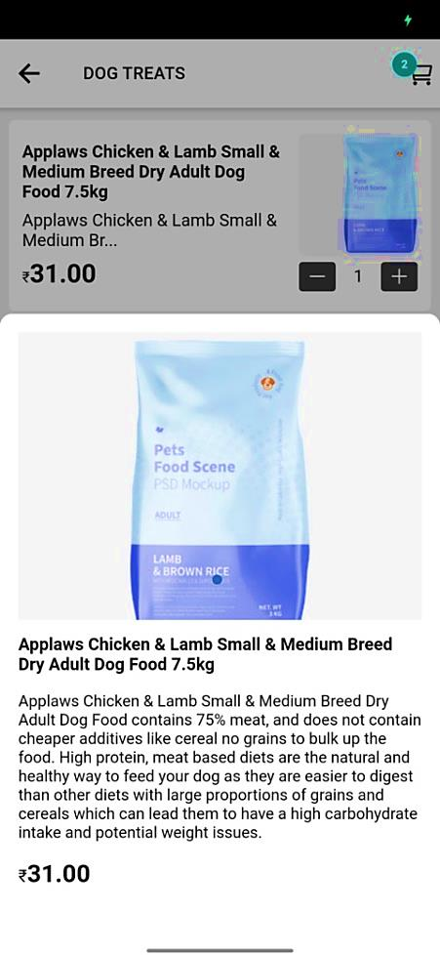

**Fig. 6.2.6 Product Information**

The user can see the various products and can check the information about the product.

52

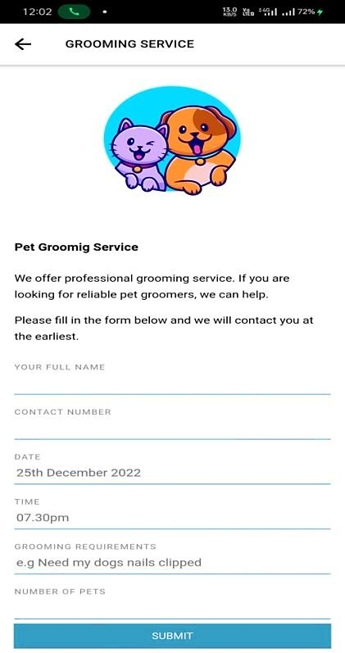

**Fig. 6.2.7 Grooming**

After successful creation of account, the customer can book grooming services.

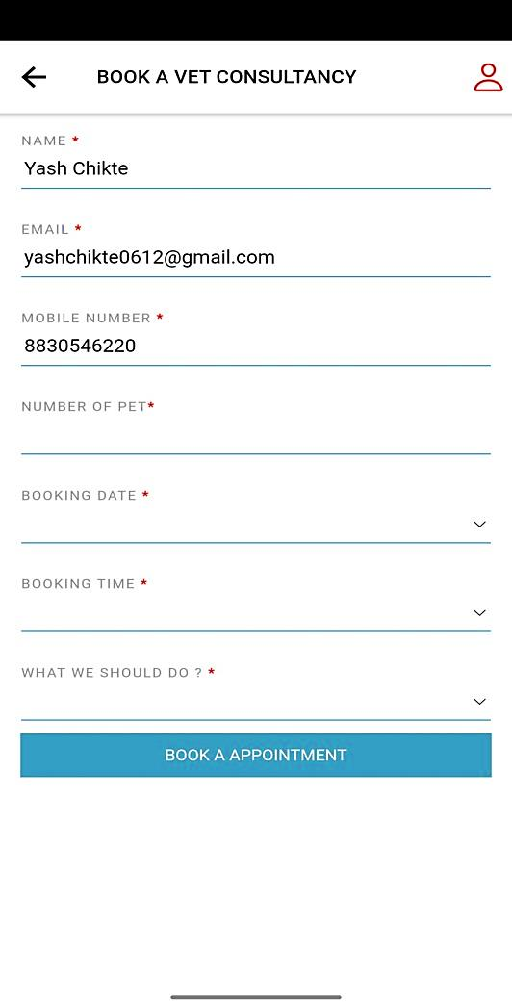

**Fig. 6.2.8 Vet Consultancy**

The user can book vet consultation for their pets.

53

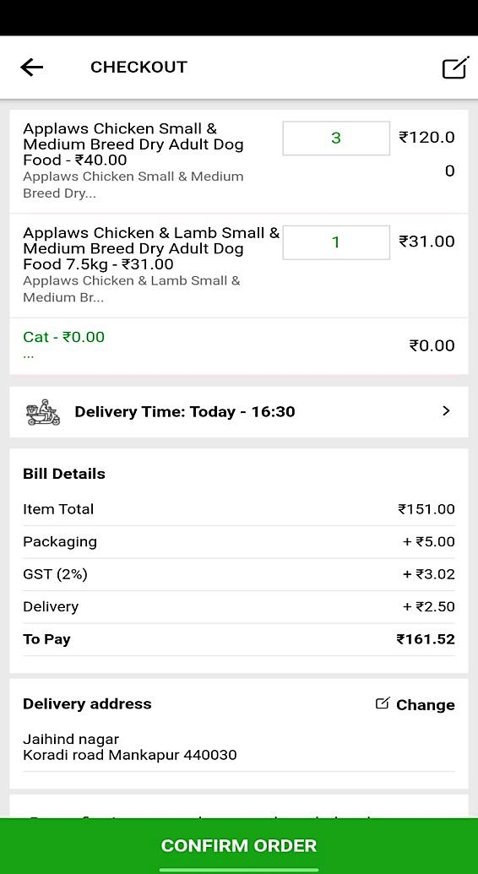

**Fig. 6.2.9 Checkout**

Here the user can see what he has ordered and can add the delivery date and can add address and confirm the order.



**Fig. 6.2.10 Payment**

The user can pay online by card or by cash.

54

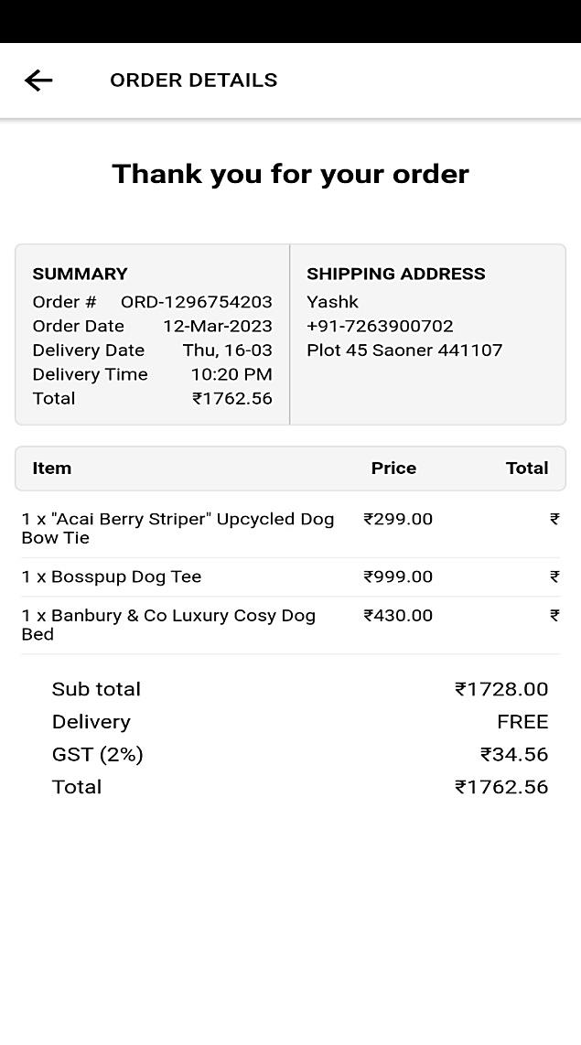

**Fig. 6.2.11 Order Details**

The user/ customer can see his/her orders after payment.

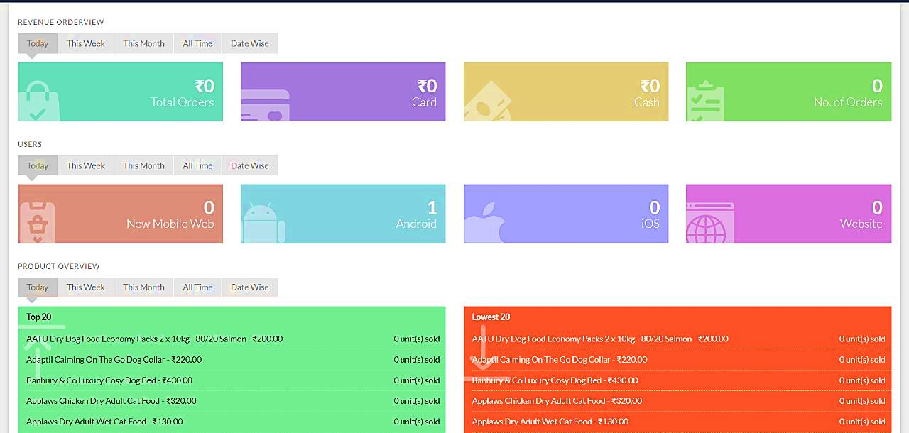

**Fig. 6.1.12 Admin Dashboard**

This is the admin dashboard where the admin can see current orders, revenue, etc.

55

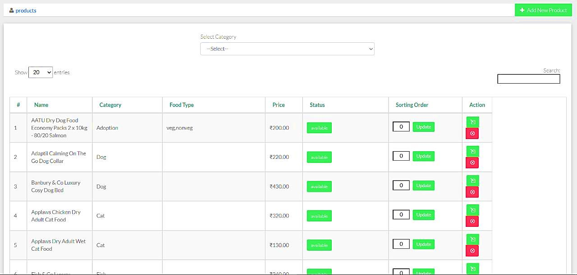

**Fig. 6.1.13 Admin User Details**

The admin can see the details of the users who login into the application.

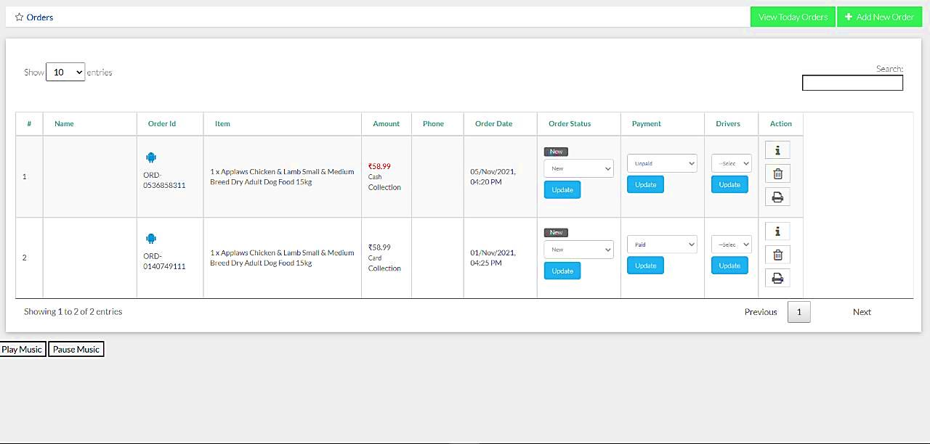

**Fig. 6.1.14 Admin Orders**

The admin can manage orders. The admin can add or remove products as well as the admin can accept or reject appointments.

56

**CHAPTER NO. 7**

**ADVANTAGES AND APPLICATIONS**

**CHAPTER 7**

**ADVANTAGES AND APPLICATIONS**

**7.1 ADVANTAGES**

1. **User Friendly**

The app is easy to use, and the user doesn’t need to have advanced technical knowledge. This is the advantage for users to view the services easily without any complications. The app has user friendly interface and is easy to handle. The customers can easily sign up by giving proper credentials and verifying their email. Then customers can easily login with username and password. The customer can book service and pay online by card or UPI for the services he opted for. The service provider has the access to add their services and manage customer as well he can approve or decline any bookings placed by the customer.

1. **Online over Offline**

Changing lifestyle, increasing incomes and nuclear families had led people to prefer the best services for their pets as they consider their pets as their family member. Booking those services and finding the right shop offline is difficult but comparing different shops as well as their price range online will help them to compare easily and book the best services for their pets.

1. **Easy Availability**

We have multiple service providers registered in our app which means a greater number of services. This will not cause a shortage of services in the city. This will also help the customer to get almost all kinds of services across the city. Our app is the one step solution for the customers who require pet food, grooming, training, day care and boarding for their pets.

57

**7.2 APPLICATIONS**

* This will be a one-stop solution to get all kinds of services for pets.
* Veterinary services can be used to treat many kinds of diseases in pets.
* Pet grooming has a great significance in this modern world.
* Service providers/ Doctors can list themselves in our application and provide their services.
* Pet day care and boarding will provide the pet parent to go out of town for days.

58

**CHAPTER NO. 8**

**CONCLUSION & FURTHER SCOPE**

**CHAPTER 8**

**CONCLUSION**

**8.1 CONCLUSION**

In this project, we have **designed** an application and completed its development by applying **engineering knowledge** which provides an approach in building a platform where customers can view and book services online from our application. We have **analysed and identified** that many people preferring the best services for their pets from our **real time survey**. Changing lifestyle and increasing income of customer has led customers to choose between the best services across the city. But getting all those services sometimes get difficult. The consumers must search for service providers and most of the times due to less availability of the shops and the services they do not get those services for their pets. Seeing such problems, we developed such kind of an application so that the customers can get all kinds of grooming services as well as veterinary services required for the treatment of their pets. And as there are many service providers there will be less shortage of shops. So, we created the project in two modules **user** and **admin**. We used modern tools like Ionic to make this project. During the development of the project, we understood the importance of **individual and teamwork** while **project development and management**. While showcasing our project through various seminars and conference we enhanced our **communication skills** and displayed **professional ethics** which results in **lifelong learning**.

**8.2 FURTHER SCOPE**

In the future, we will implement the application with additional features like a daycare facility where pet owners can keep their pets with us while they are away for work or even on vacation. We may also include the feature of training specially for dogs whose pet owners are interested in taking their dogs to dog shows. We may also include cloud computing architectures to minimize the load of the application on mobile devices.

59

**REFERENCES**

**Papers:**

1. Wikipedia,2010. Hewn timangan. [Online]. Tersedia: id.wikipedia.org/wiki/hewan_timangan. [Di Akses 14 Juni 2017].
2. Yang, Y., Zhang, Y., Xia, P., Li, B., & Ren, Z. (2017, December). Mobile terminal development plan of cross-platform mobile application service platform based on ionic and Cordova. In 2017 International Conference on Industrial Informatics Computing Technology, Intelligent Technology, Industrial Information Integration (ICIICII) (pp. 100-103). IEEE.
3. Chen Laihua. The status quo, influencing factors and development trend of China's pet industry [J], China Animal Health, 2018.08.
4. BOZKURT, Alper et al. Toward cyber-enhanced working dogs for search and rescue. IEEE Intelligent Systems, v. 29, n. 6, p. 32-39, 2014.
5. HUANG, Chao-Hsi; SHEN, Pin-Yin; HUANG, Yueh-Cheng. IoT-based physiological and environmental monitoring system in animal shelters. In: 2015 Seventh International Conference on Ubiquitous and Future Networks. IEEE, 2015. p. 317-322.
6. Khazan O. Is it Safe to Get Your Dog Groomed During COVID-19? The Atlantic. Available online at: https://www.theatlantic.com/health/archive/ 2020/04/it-safe-get-your-dog-groomed-during-covid-19/609982/
7. American Veterinary Medical Association. U.S. Pet Ownership & Demographics Sourcebook. American Veterinary Medical Association; Schaumberg, IL, USA: 2020. [Google Scholar]
8. Pet Grooming and Boarding – 2020 U.S. Market Research Report
9. Pet Industry Trends, Growth & Statistics in 2022 and Beyond: Unleashing Your Ecommerce Pet Marketing Strategies by Reilly Roberts, Jun. 11, 2022

**Websites:**

* https://angular.io/
* https://ionicframework.com/
* https://www.php.net/
* https://codeigniter.com/

**APPENDIX I**















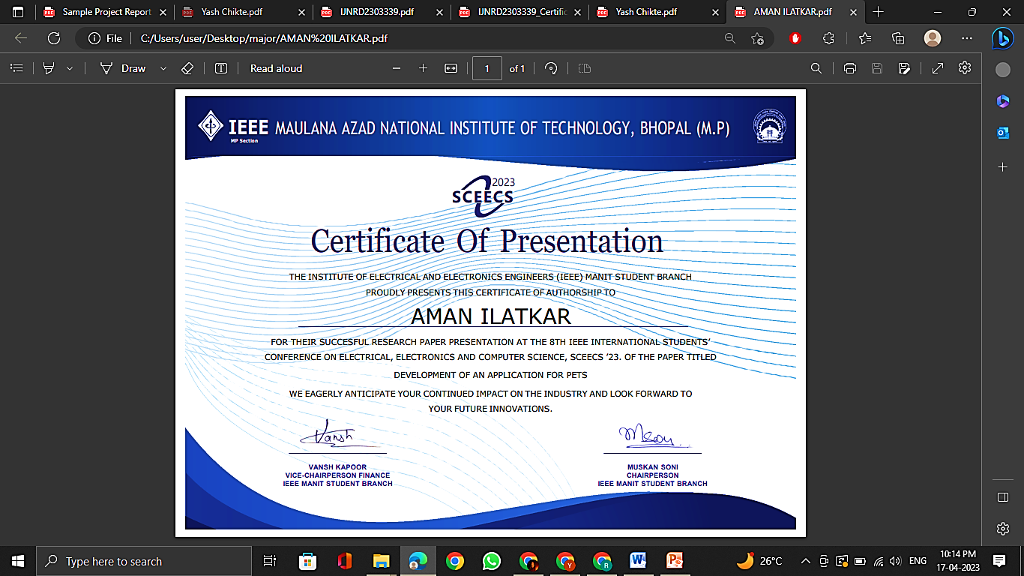

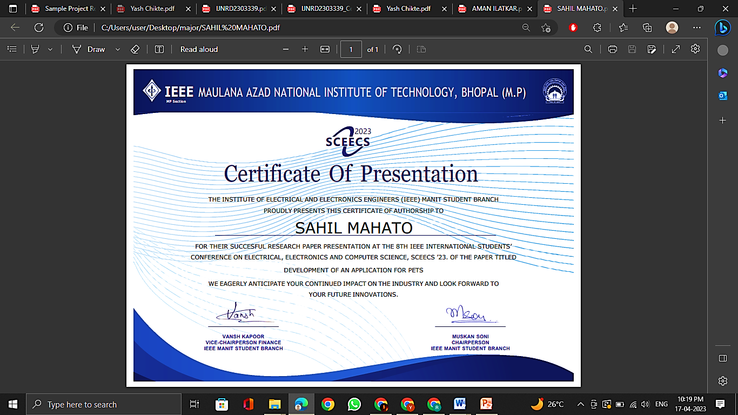

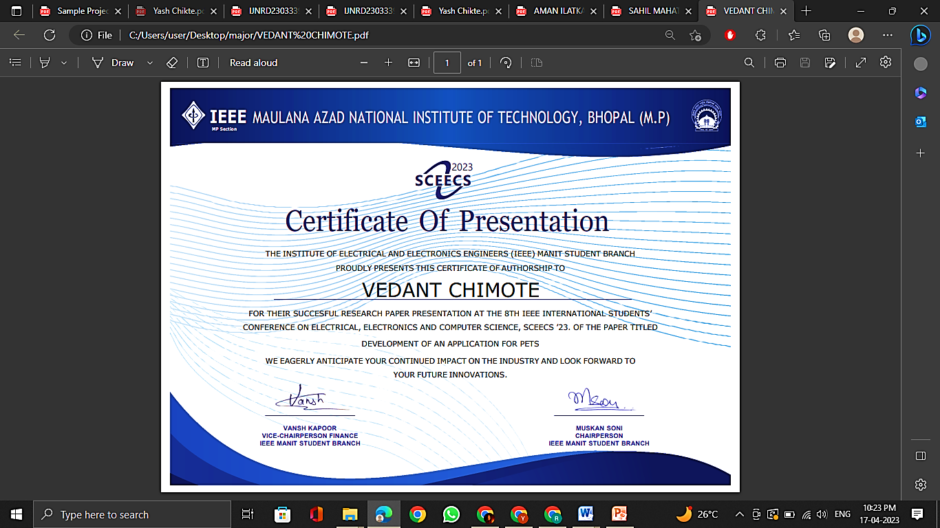

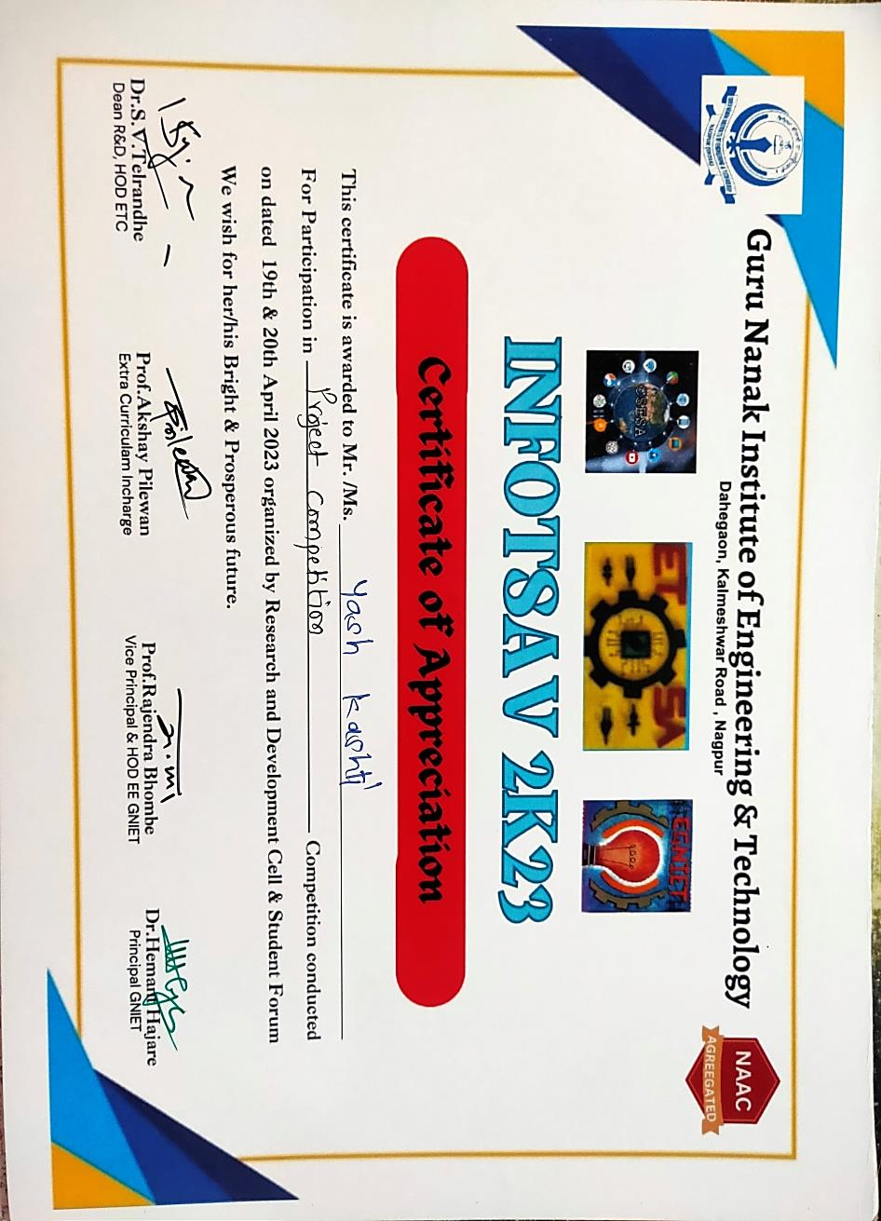

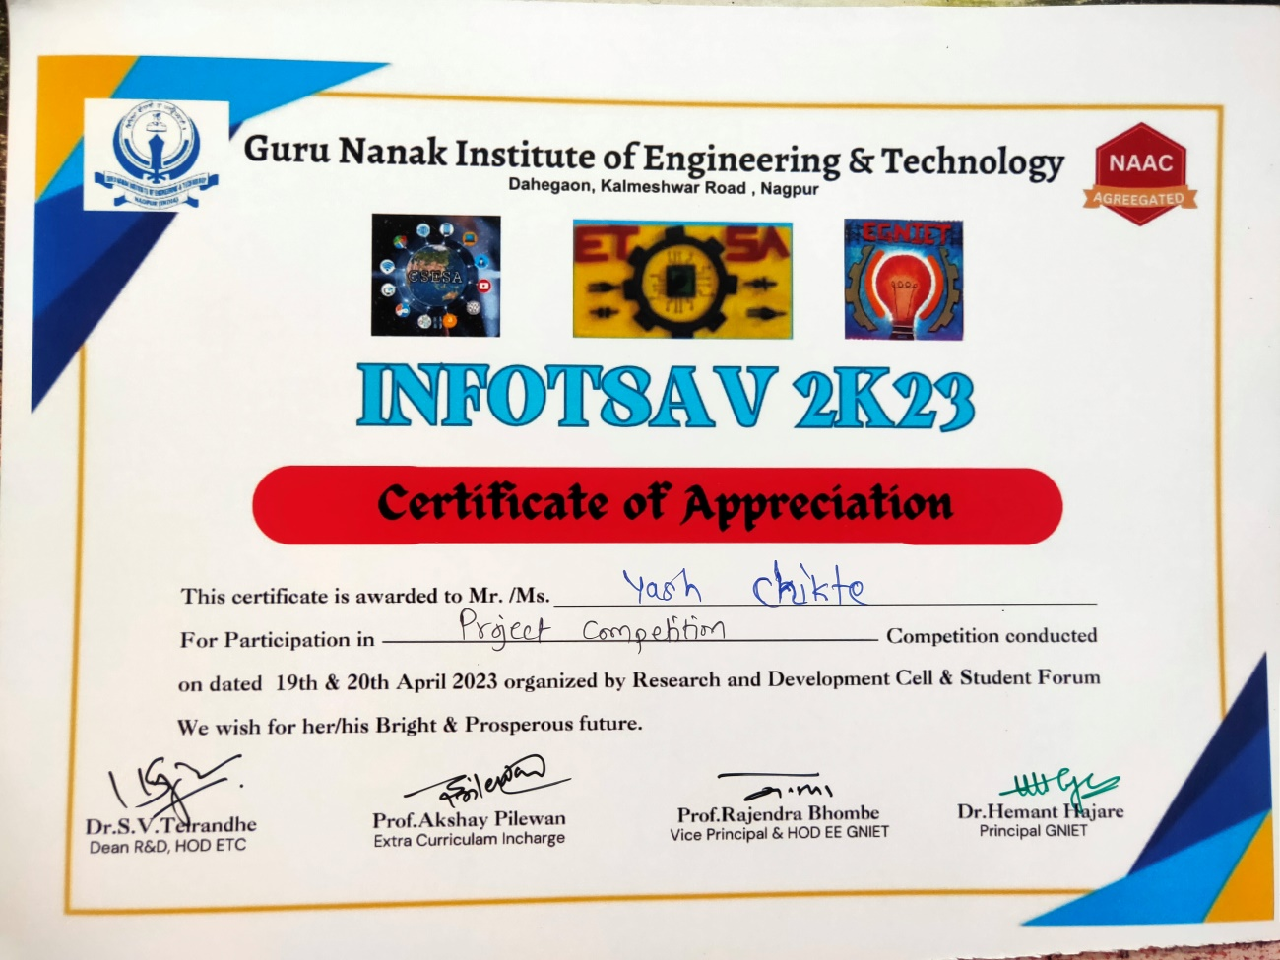

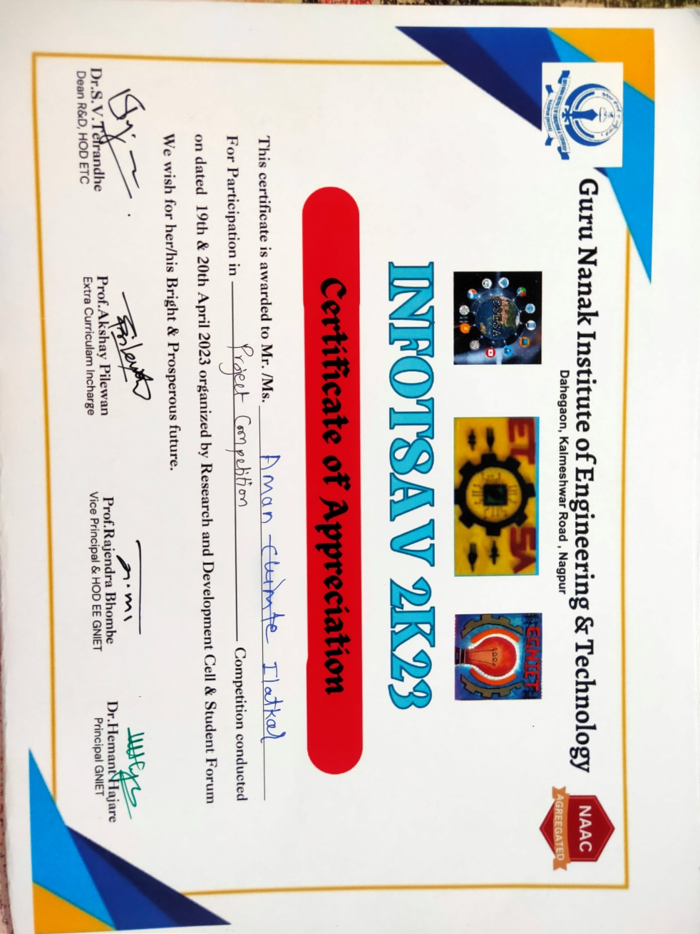

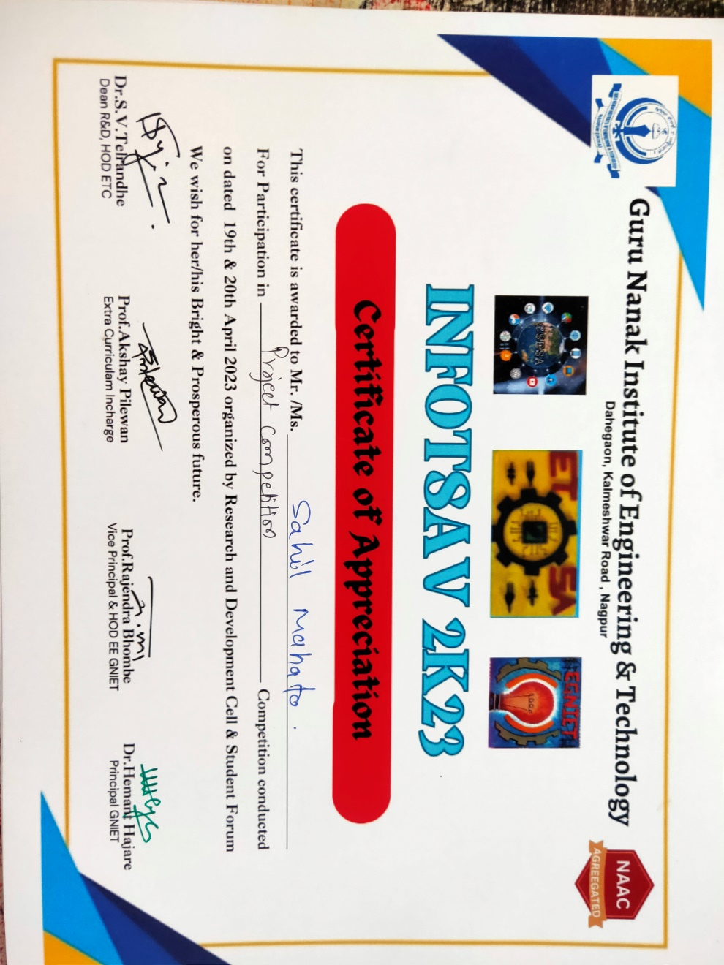

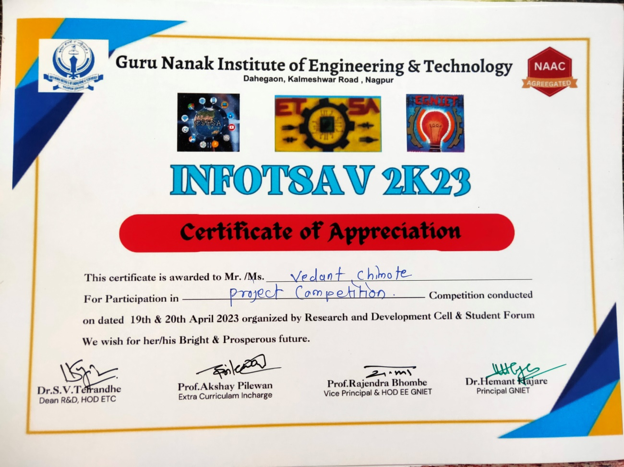

**APPENDIX II**

**APPENDIX III**

**PLAGIARISM REPORT**

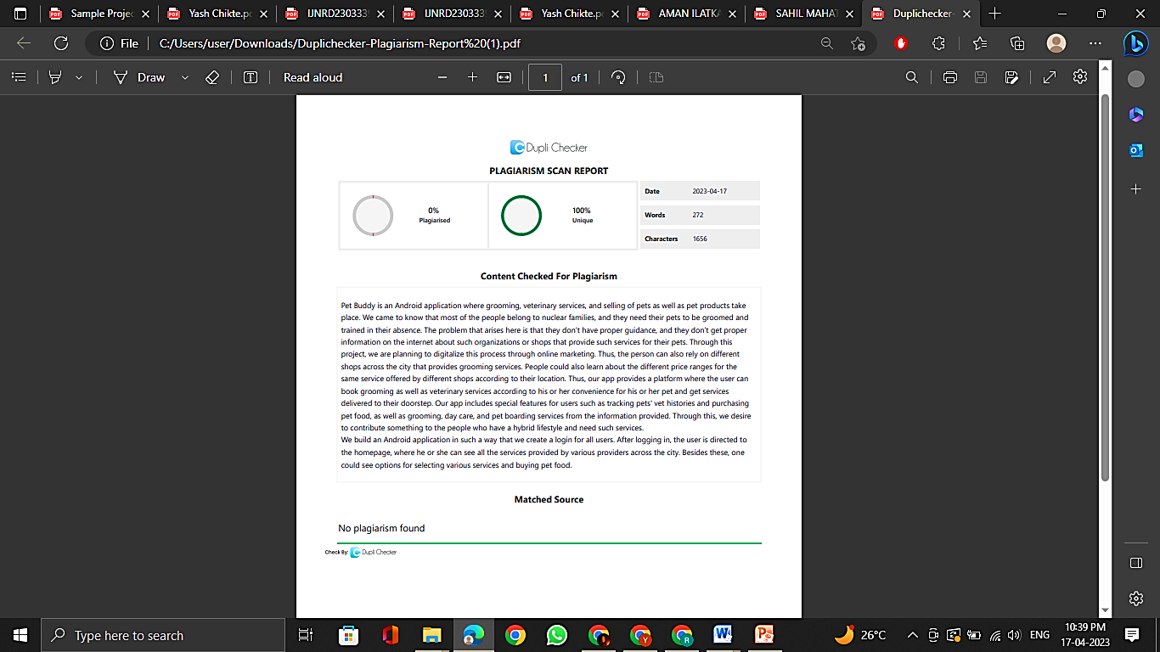

**APPENDIX IV**

**Instruction Manual**

**on**

**“Development of an Application for Pets”**

### *Submitted By*

###### Mr. YASH KASHTI Mr. SAHIL MAHATO

###### Mr. AMAN ILATKAR Mr. YASH CHIKTE

**Mr. VEDANT CHIMOTE**

# Under The Guidance Of –

1. **Mr. SWAPNIL MAHAJAN**

# **Ms. NIKITA JAMGADE**



**DEPARTMENT OF COMPUTER SCIENCE & ENGINEERING**

1. **S.B. JAIN INSTITUTE OF TECHNOLOGY, MANAGEMENT & RESEARCH, NAGPUR.**

(An Autonomous Institute, Affiliated to RTMNU, Nagpur)

**2022-2023**

**© S.B,J.I.T.M.R Nagpur 2023**

1. **Abstract**

Pet Buddy is an Android application where grooming, veterinary services, and selling of pets as well as pet products take place. We came to know that most of the people belong to nuclear families, and they need their pets to be groomed and trained in their absence. The problem that arises here is that they don’t have proper guidance, and they don’t get proper information on the internet about such organizations or shops that provide such services for their pets. Through this project, we are planning to digitalize this process through online marketing. Thus, the person can also rely on different shops across the city that provide grooming services. People could also learn about the different price ranges for the same service offered by different shops according to their location. Thus, our app provides a platform where the user can book grooming as well as veterinary services according to his or her convenience for his or her pet and get services delivered to their doorstep. Basic pet grooming includes combs and brushes, bathing, shampoos and conditioners, and nail clipping and trimming. Our app includes special features for users such as tracking pets' vet histories and purchasing pet food, as well as grooming, day care, and pet boarding services from the information provided. Through this, we desire to contribute something to the people who have a hybrid lifestyle and need such services. We build an Android application in such a way that we create a login for all users. After logging in, the user is directed to the homepage, where he or she can see all the services provided by various providers across the city. Besides these, one could see options for selecting various services and buying pet food.

1. **Modules Implemented**

**Module 1: User /Customer**

Users are the people who have the access to see the services and products for their pets. The user has the access to buy various kinds of products for their pets as well as they can avail the services for them. We created the mobile application with the help of Ionic and Angular Framework.

1.1 **Home**: User/Customer can search for various kinds of products for their pets and, they can book appointments for vet as well as for grooming services.

1.2 **Order/Appointment Management**: Users/customers can view and process orders and pay for same also book an appointment for services.

1.3 **Customer Managements**: User/customer can Login/ log out, View/ Update Profile.

**Module 2: Admin**

Admin panel is a backend area used to make a new entry of products and pets for adoption with some basic details. And can manage and access payment of the user. We used SQLITE as a database to store our data.

2.1 **Admin Dashboard**: Admin can see all records of the products, services, and orders.

2.2 **Manage Products**: Admin can Add/update and delete products as well as pets and services.

2.3 **Admin Management**: Admin can Login/ Log out.

1. **Software and Hardware Requirements**

**3.1 Software Requirements**

1. **Operating System**: Windows 7 or Higher

2. **Web Framework**: Ionic Framework

3. **Server-Side Technology**: PHP, CodeIgniter Framework

4. **Client-Side Technology**: Ionic, Angular Framework

5**. Database:** MySQL

6. **Designing Tool**: Draw.io

7. **Libraries Used**: Stripe

**3.2 Hardware Requirements**

* **Android Version:** 8 or above.
* **Requirement:** Internet Connection
* **Ram:** Minimum 2 GB

**3.3 Flowchart**

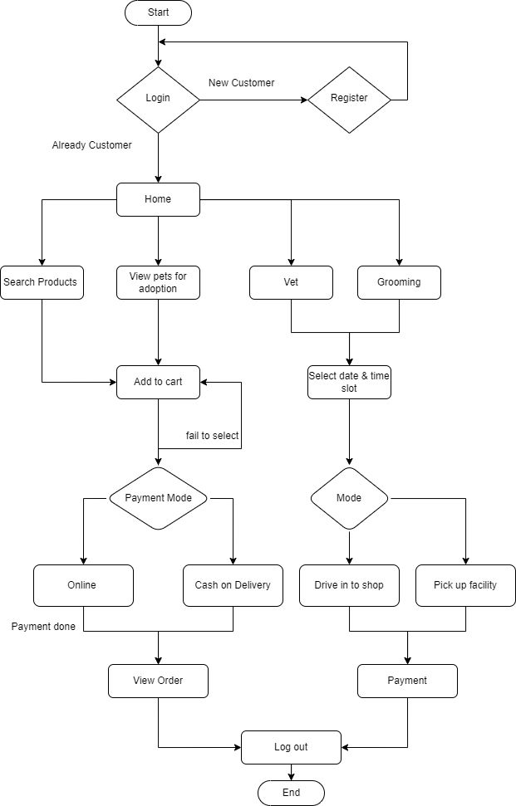

1. **Steps to Run the Project**
2. Extract all the files on your Mac System / Windows PC
3. Open terminal from user app folder or use Putty if you are using a Windows PC
4. Type "npm install"
5. Go to project folder > src > environments
6. Open environment.ts and environment.prod.ts file then change all the credentials as relevant.
7. Open terminal and type "ionic cordova platform add android”
8. After the above step type “ionic cordova build android”
9. Connect device or open simulator for app to run.
10. Open terminal and type "ionic cordova run android".
11. **Future Scope**

In the future, we will implement the application with additional features like a daycare facility where pet owners can keep their pets with us while they are away for work or even on vacation. We may also include the feature of training especially for dogs whose pet owners are interested in taking their dogs to dog shows. We may also include cloud computing architectures to minimize the load of the application on mobile devices.

1. **Limitations**

* App not available intercity.

*\*

**APPENDIX**